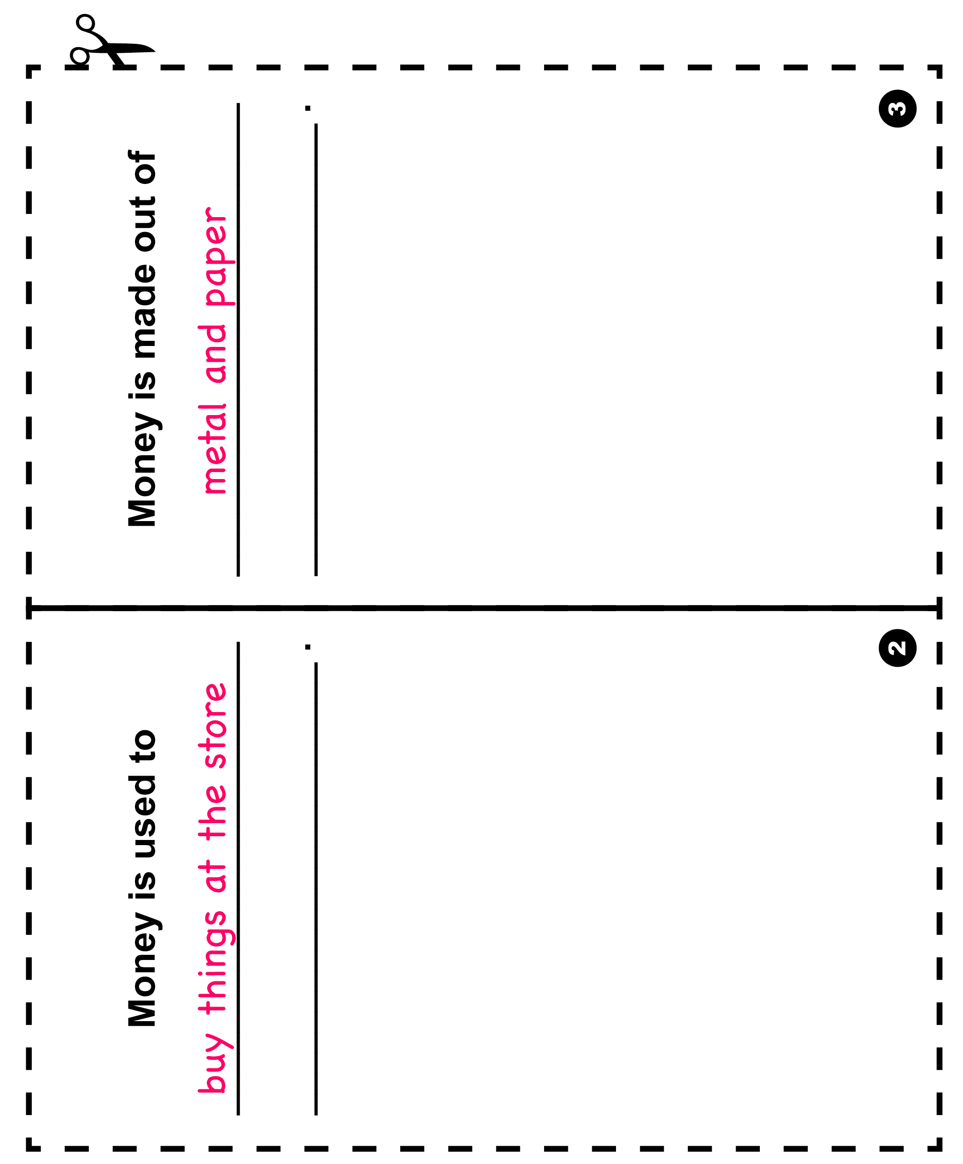Description: copDescription: Construction WorkerDescription: ScientistDescription: ArtistDescription: chefDescription: nurse2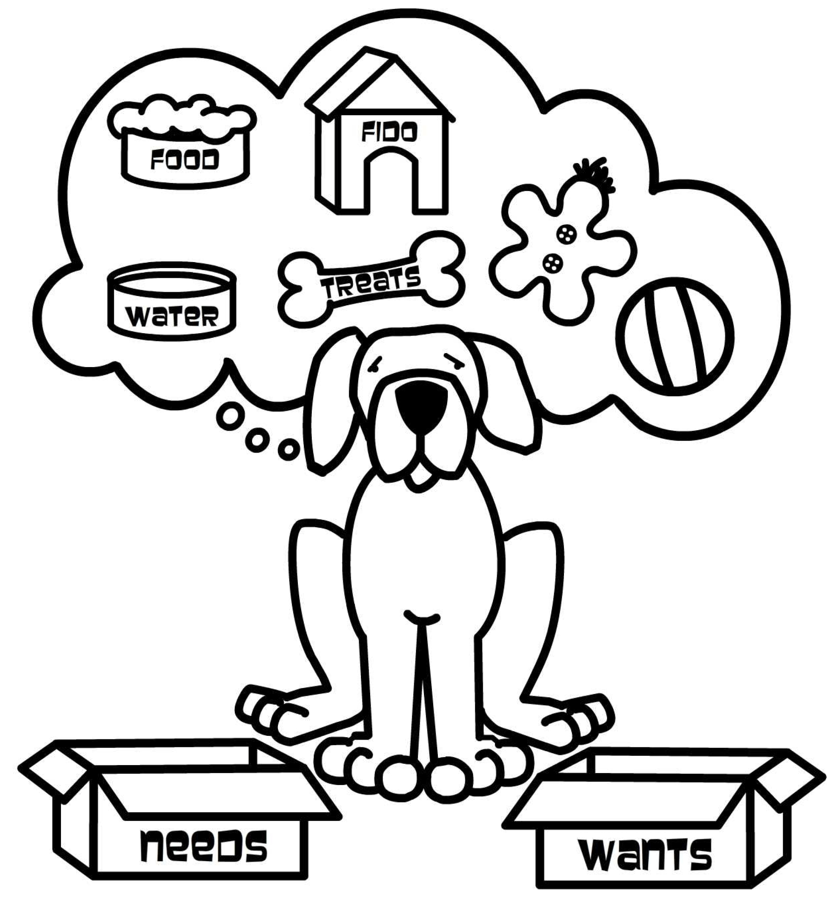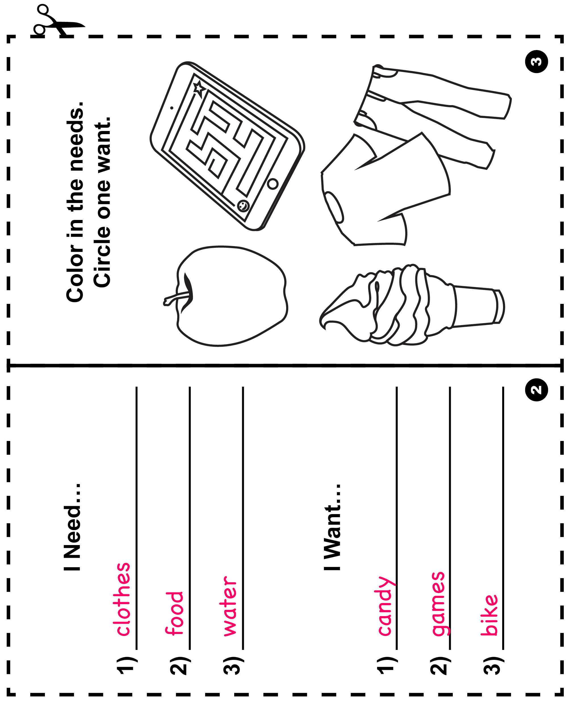Description: AppleDescription: Teddy BearDescription: snakeDescription: Gum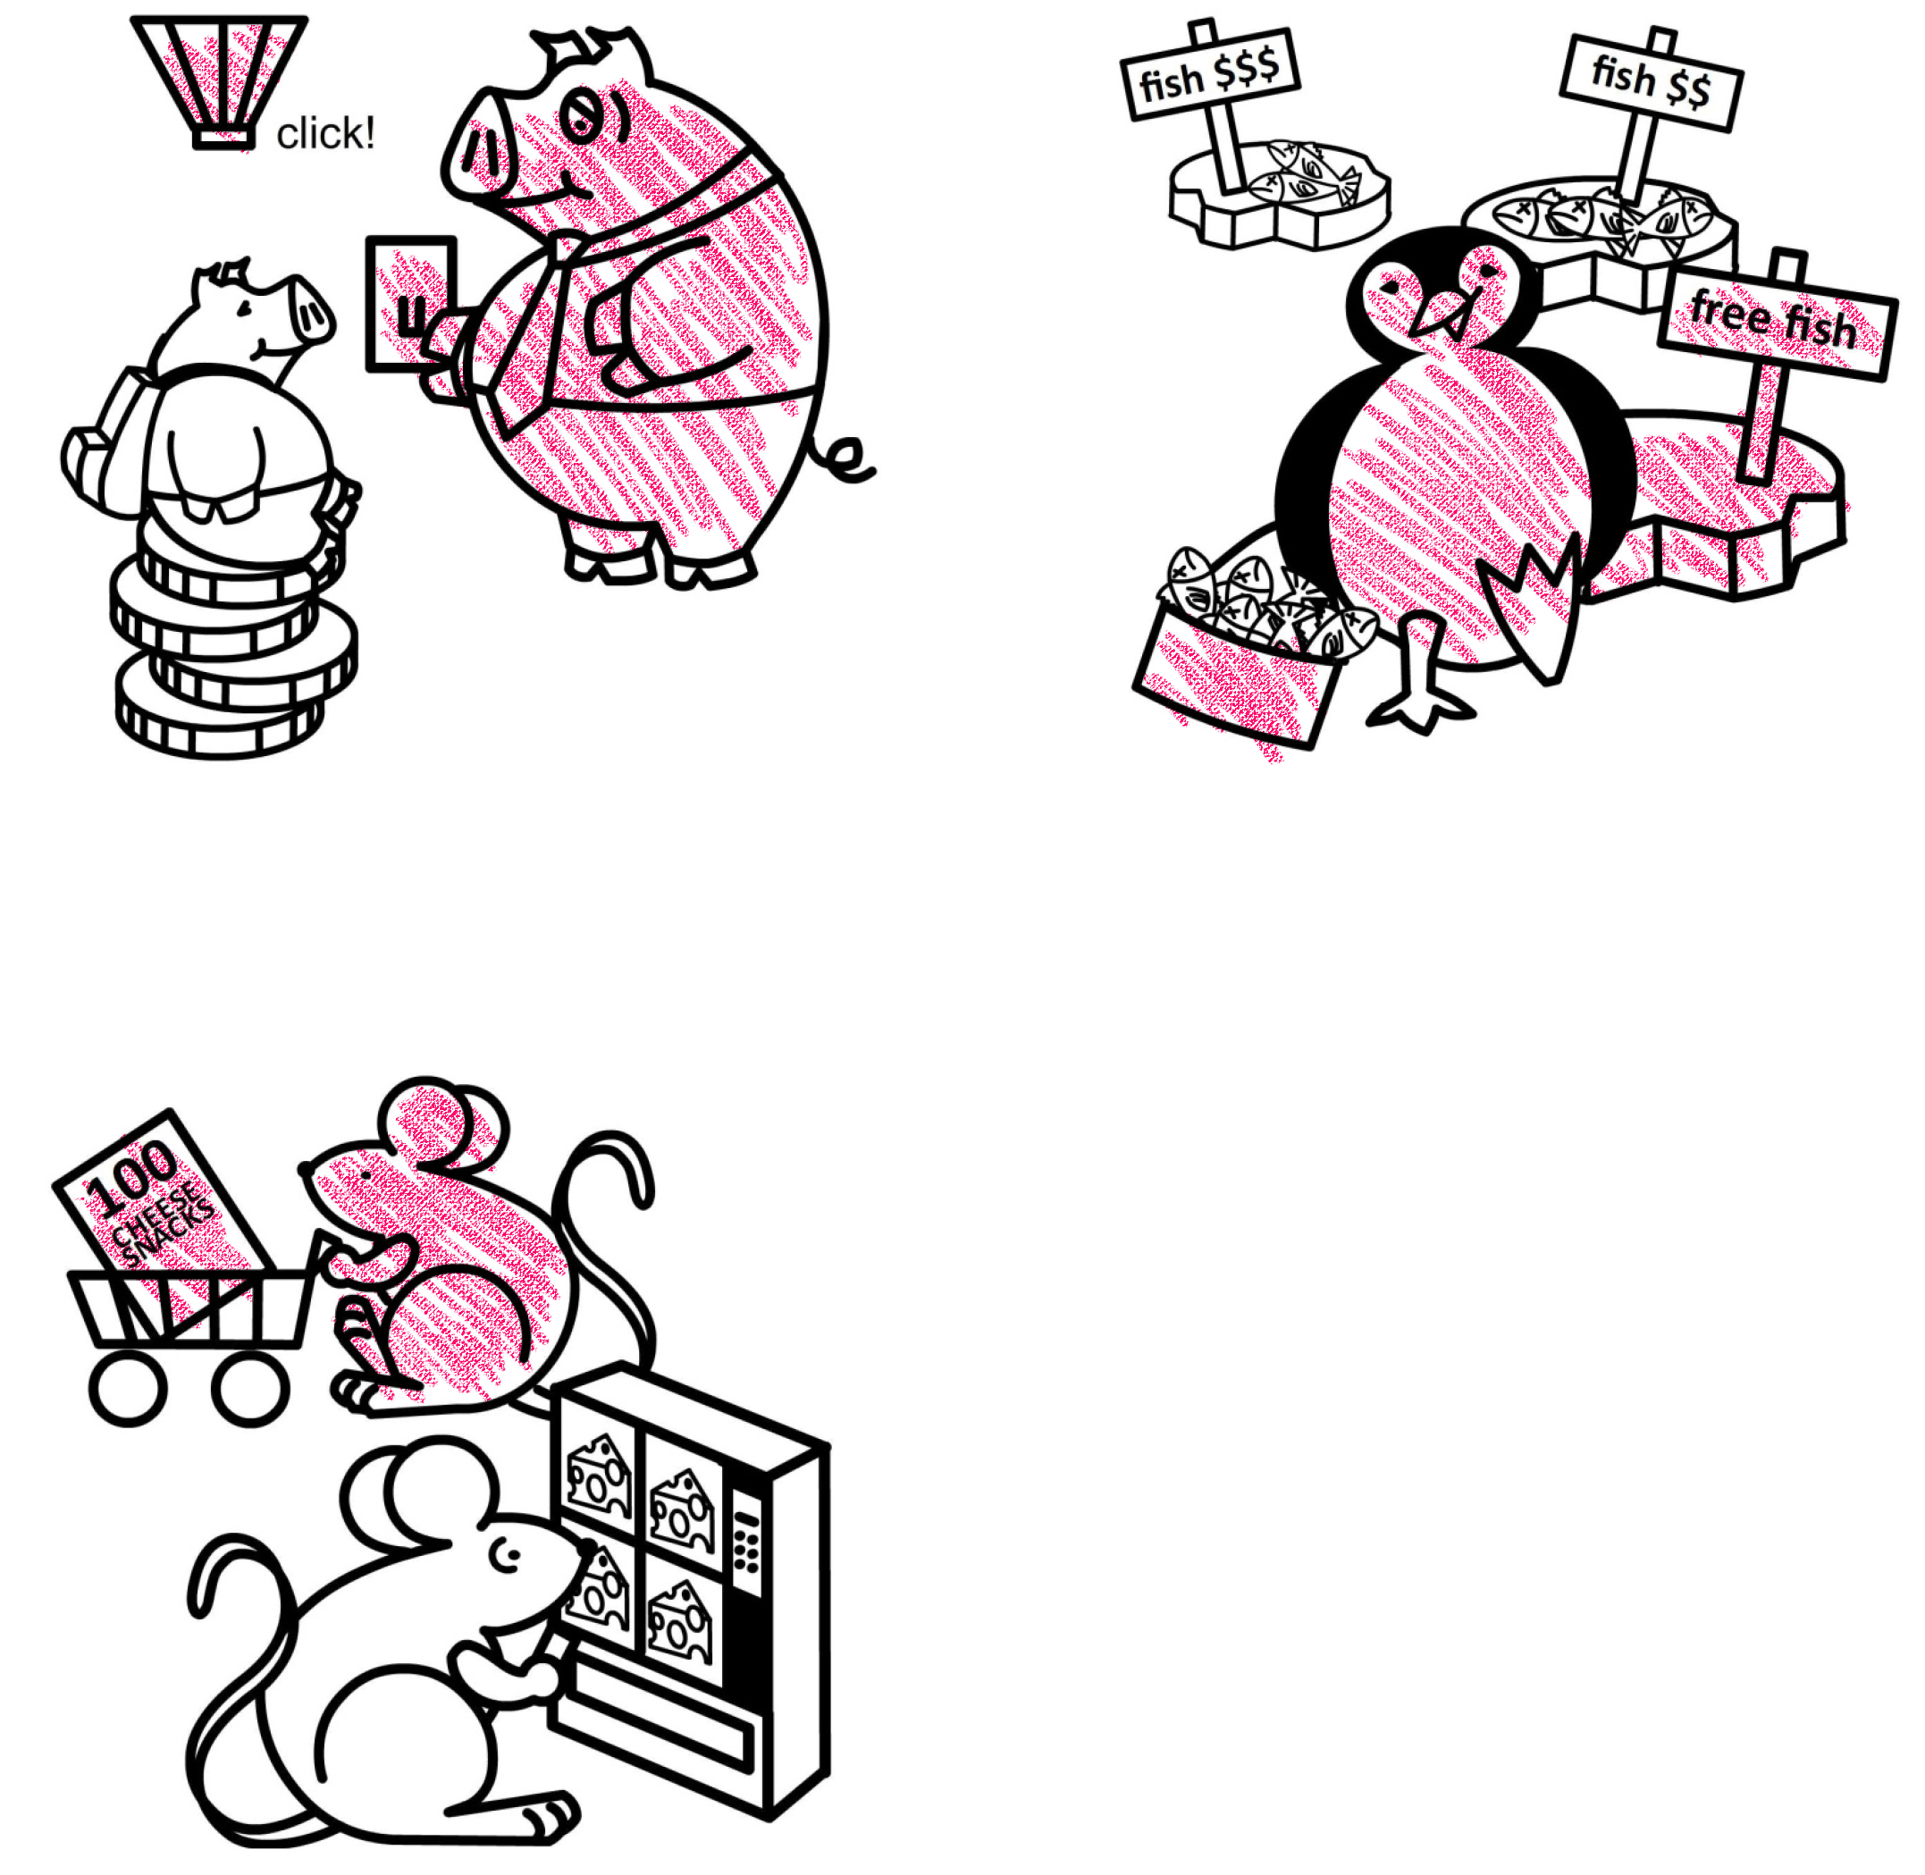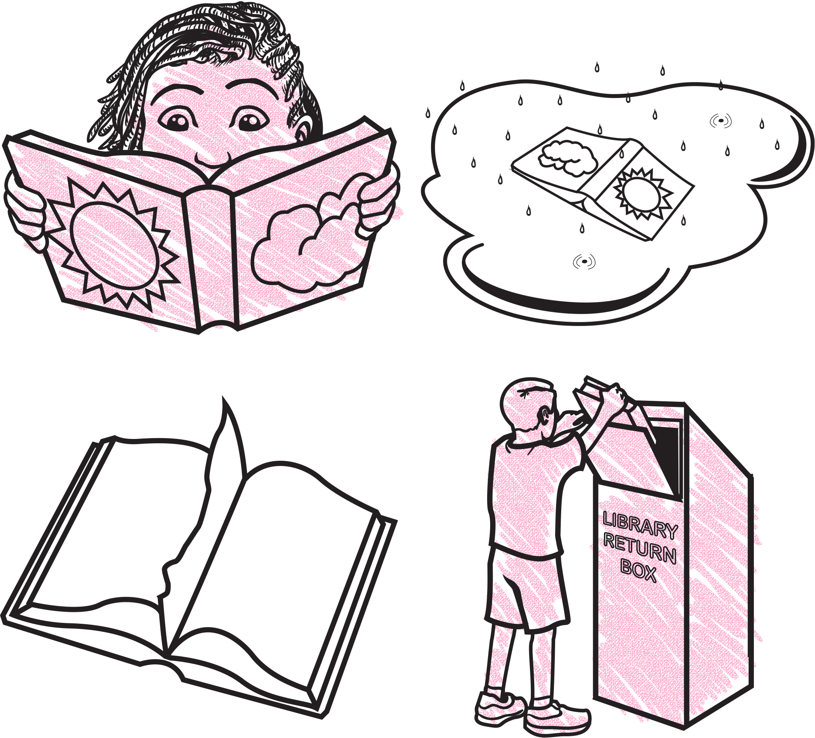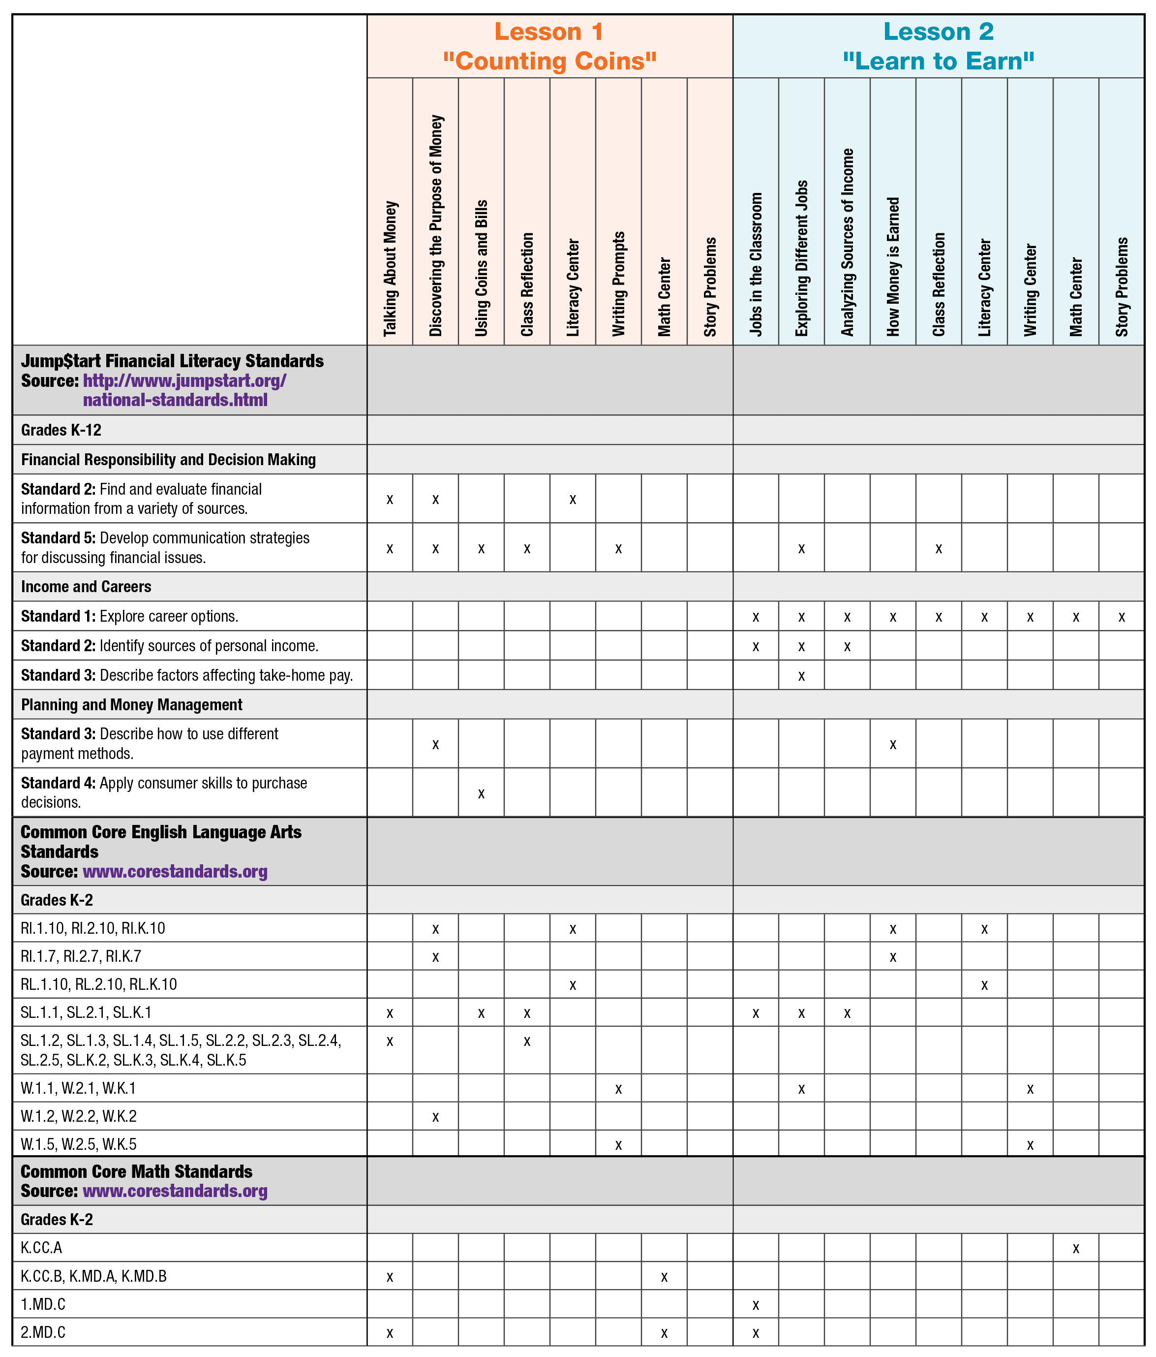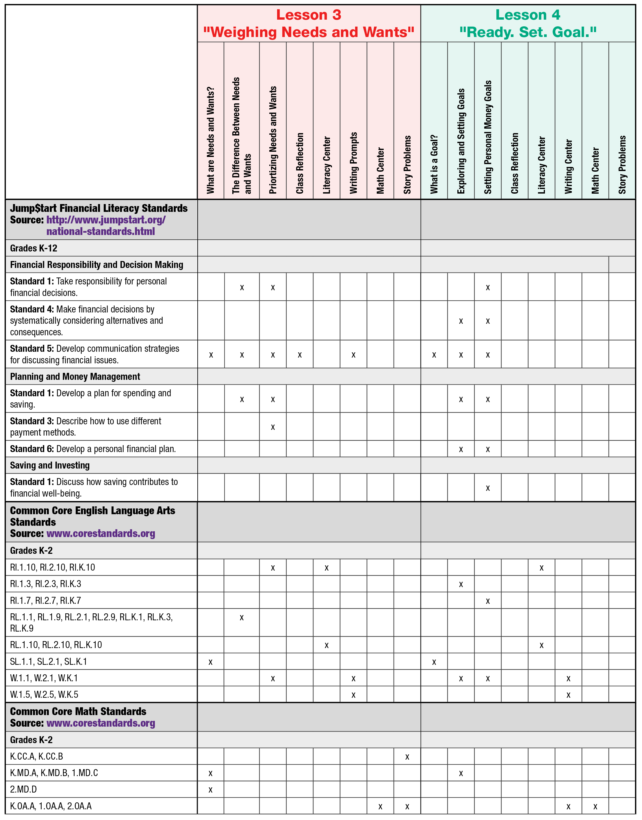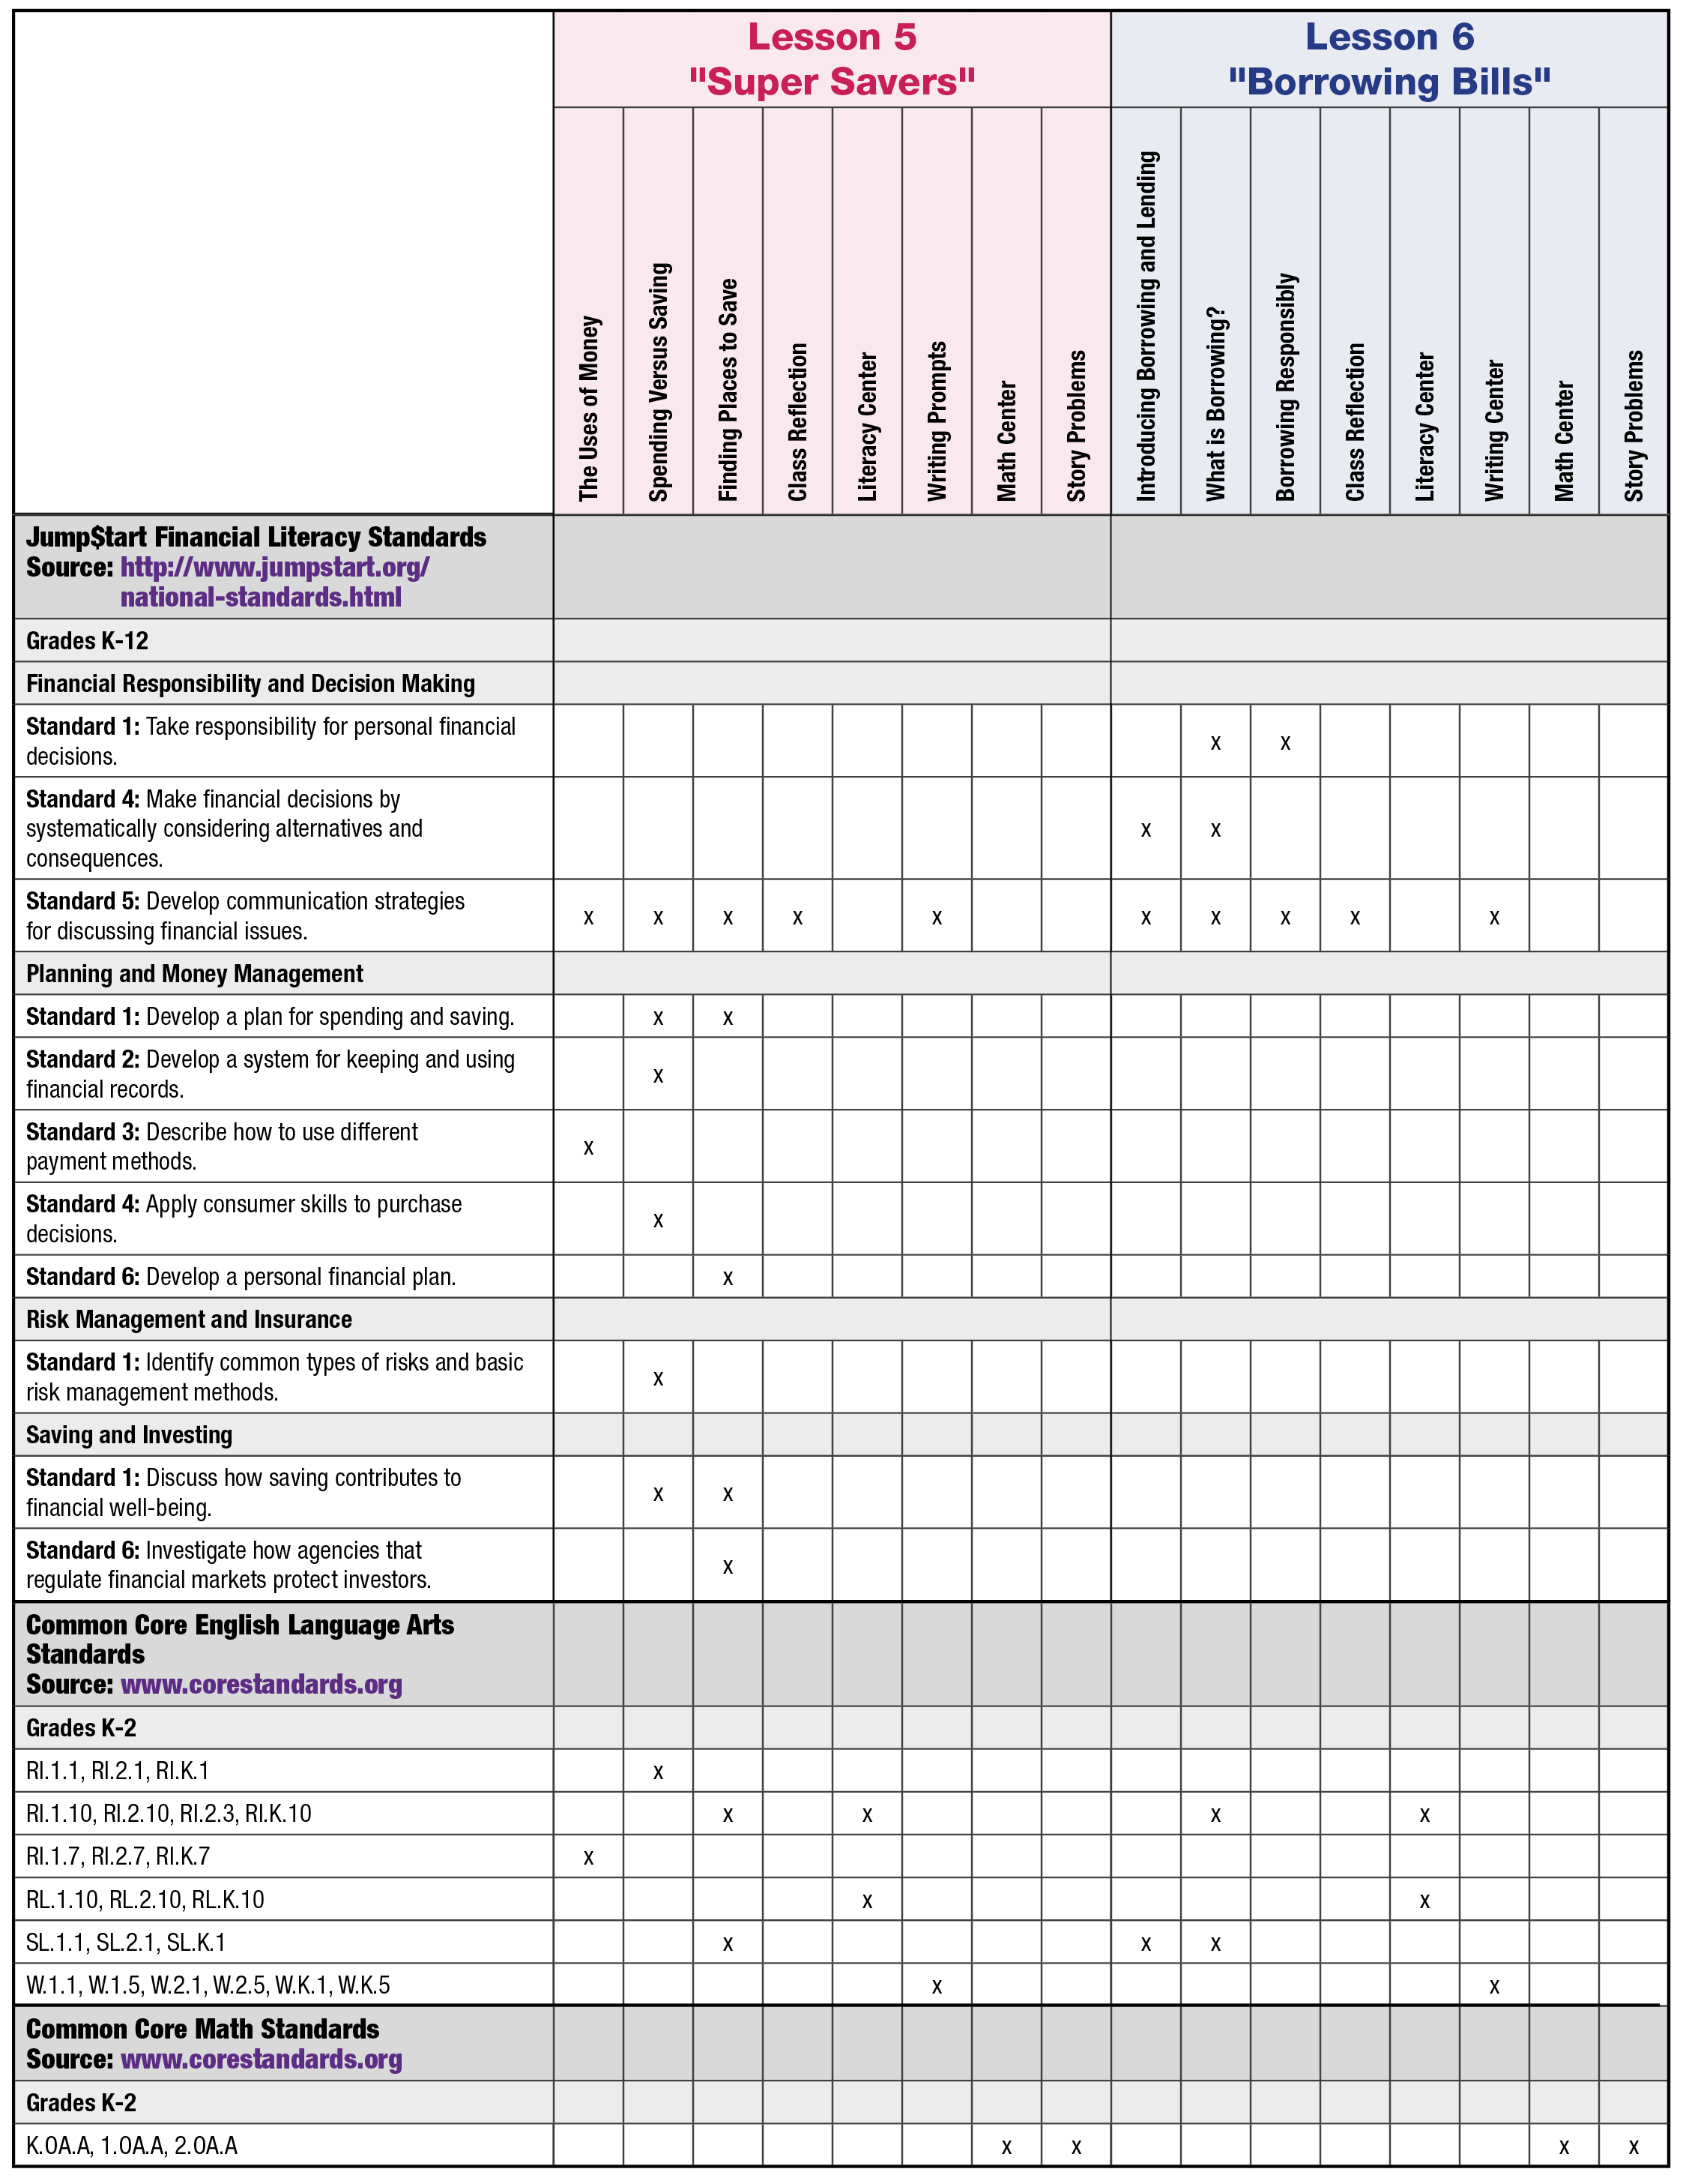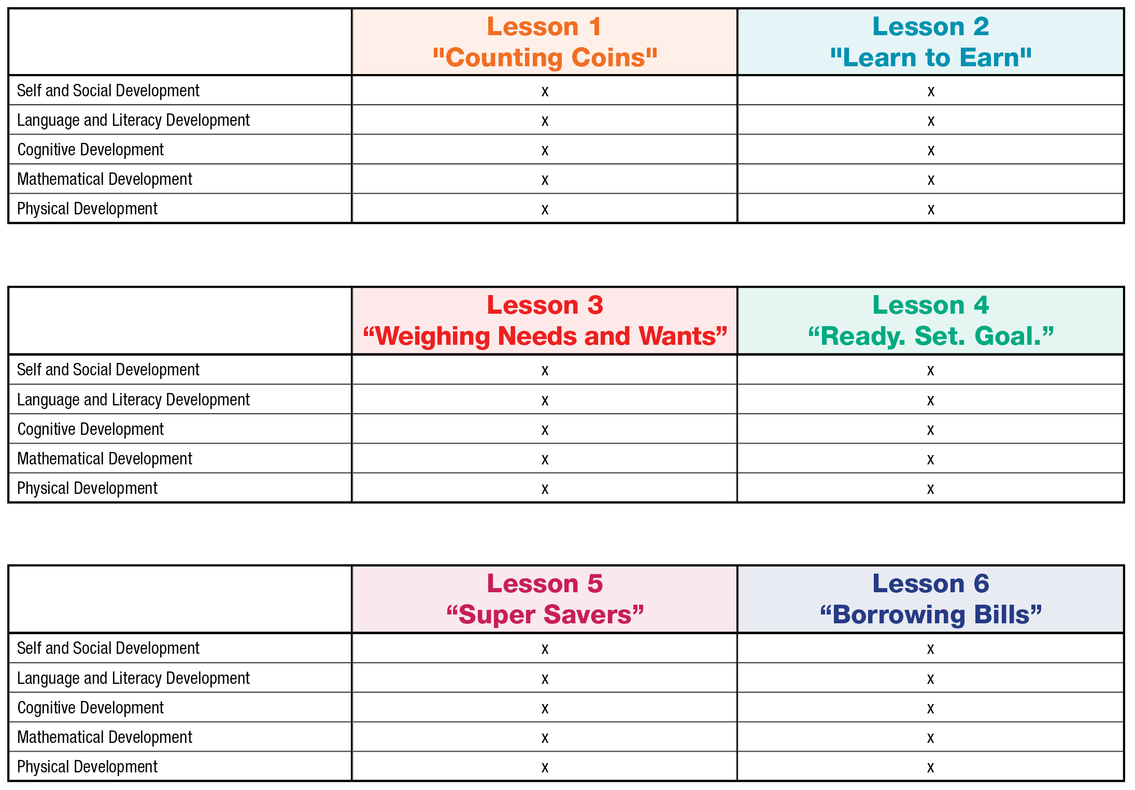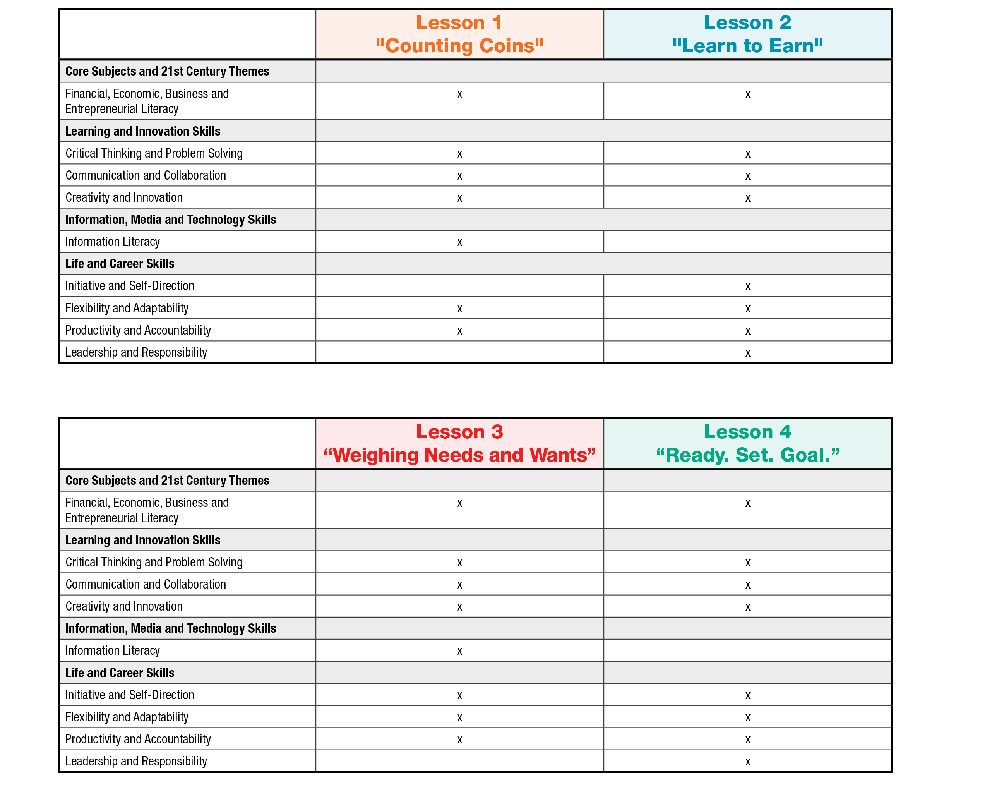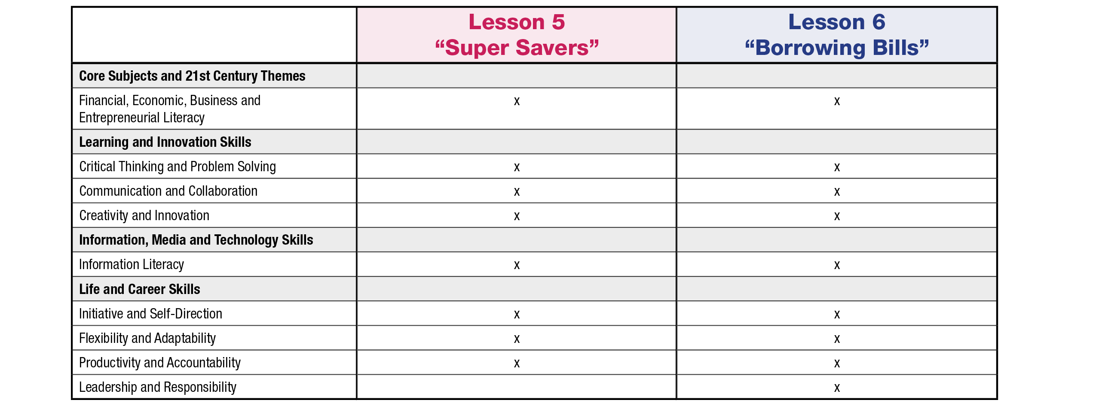

**ANSWER KEY**

**MY “HISTORY OF MONEY” Mini-Book (continued)**

**ANSWER KEY**

Jobs and action words

**Name: ____________________________________________________**

**Match each job with the correct action word.**

**Construction**

**Worker**

**Police Officer**

**CARE COOK RESEARCH PROTECT PAINT BUILD**

**Nurse**

**Chef**

**Artist**

**Scientist**

**ANSWER KEY**

needs and wants

**Name: ____________________________________________________**

**Fido has a list of things he needs and wants. Help him choose what is a need and what is a want. Draw a line from each item to the correct box.**

**ANSWER KEY**

**MY Needs and Wants Mini-Book (continued)**

Student answers will vary. Use handout to assess student ability to evaluate wants from needs and understanding of spending versus saving.

**ANSWER KEY**

Food = Need

Pet = Want

Candy = Want

spending choices

**Name: ____________________________________________________**

**Imagine you have three quarters. How much money do you have? Look at the items you can buy. Color then cut and paste the items you are going to buy. What did you choose and why? How much money do you have left? How much have you saved?**

|  |  |  |  |
| --- | --- | --- | --- |
| **1.** | **2.** | **3.** | **4.** |

|  |  |  |  |
| --- | --- | --- | --- |
| **3 Pieces of Gum**  **15¢** | **Snake Rental**  **25¢** | **Apple**  **11¢** | **Yard Sale**  **20¢** |

Toy = Want

**ANSWER KEY**

**Shop around for the best deal.**

**Turn off the lights if you are not in the room.**

**Buy snacks on sale at the grocery store instead of buying them from a vending machine.**

**Can you think of another way to save money? Draw your own money-saving activity below.**

savings tips

**Name: ____________________________________________________**

**Saving money is important. What are some things you can do to start saving money? Look at, then color the money-saving activities below.**

**ANSWER KEY**

ways to borrow and share

Name: ____________________________________________________

Color in the examples of how we should treat things that we borrow or share.

|  |  |  |  |  |  |
| --- | --- | --- | --- | --- | --- |
| |  |  | | --- | --- | |  |  | |  |  | |  |

glossary

**Bank:** A financial institution and business that accepts deposits and makes loans.

**Borrow:** To receive something on loan with the understanding that you will return it.

**Currency:** A form of money that is generally accepted to measure value (banknotes, bills, coins, and so on).

**Earn:** To receive money in exchange for goods or services

**Federal Deposit Insurance Corporation (FDIC):** Preserves and promotes public confidence in the U.S. financial system by insuring deposits in banks and thrift institutions for at least $250,000. An independent agency of the federal government, the FDIC was created in 1933.

**Goal:** Something, such as an outcome, you wish to achieve or accomplish in a specific amount of time.

**Income:** Money that you receive from jobs, gifts, allowances, interest, dividends, and other sources.

**Job:** A specific duty, task, or activity someone completes using his or her time, skills, and energy to earn money.

**Lend:** The act of giving something to someone with the understanding that they will give it back to you.

**Money:** Money is an object you can use to purchase goods and services. Money looks different in different places around the world.

**Need:** Something you must have to survive, such as clothes, shelter, or food.

**Save:** Setting something, like money, aside to use in the future.

**Spend:** The act of using money to buy goods or services.

**Want:** Something that you would like to have but that you could live without.

education standards

**Jump$tart Financial Literacy, Common Core English Language Arts and Math**

education standards (continued)

education standards (continued)

**National Early Childhood Learning Outcomes**

**Sources:**

http://www.desiredresults.us/docs/docs_forms/DRDP-SA(2011)%20Complete100311.pdf

<http://www.naeyc.org/files/naeyc/file/positions/earlyLearningStandards.pdf>

<http://www.ed.gov/early-learning>

http://www.desiredresults.us/docs/Forms page/DRDP (2010)/PS_Final_8-26.pdf

education standards (continued)

Early learning standards provide desired outcomes for young children's education. The **National Association for the Education of Young Children** (NAEYC) and the **National Association of Early Childhood Specialists in State Departments of Education** (NAECS/SDE) believe that early learning standards are an important part of comprehensive, high-quality services for young children. The ***Money Smart*** lessons have been designed to integrate key domains identified by the **U.S. Department of Education**, providing relevant guidelines for preschool and early school age children.

**Partnership for 21st Century Skills**

**Partnership for 21st Century Skills**

**Partnership for 21st Century Skills**

**Partnership for 21st Century Skills**

**Partnership for 21st Century Skills**

**Partnership for 21st Century Skills**

**Partnership for 21st Century Skills**

**Partnership for 21st Century Skills**

Continued…

21st century skills are incorporated into the curriculum wherever possible. These important skills prepare students with the ability to navigate the complex life and work environments in today's competitive world. An essential piece in this curriculum is Financial, Economic, Business and Entrepreneurial Literacy.

education standards (continued)

education standards (continued)

**Sources:** http://www.p21.org/our-work/p21-framework

**Partnership for 21st Century Skills (continued)**