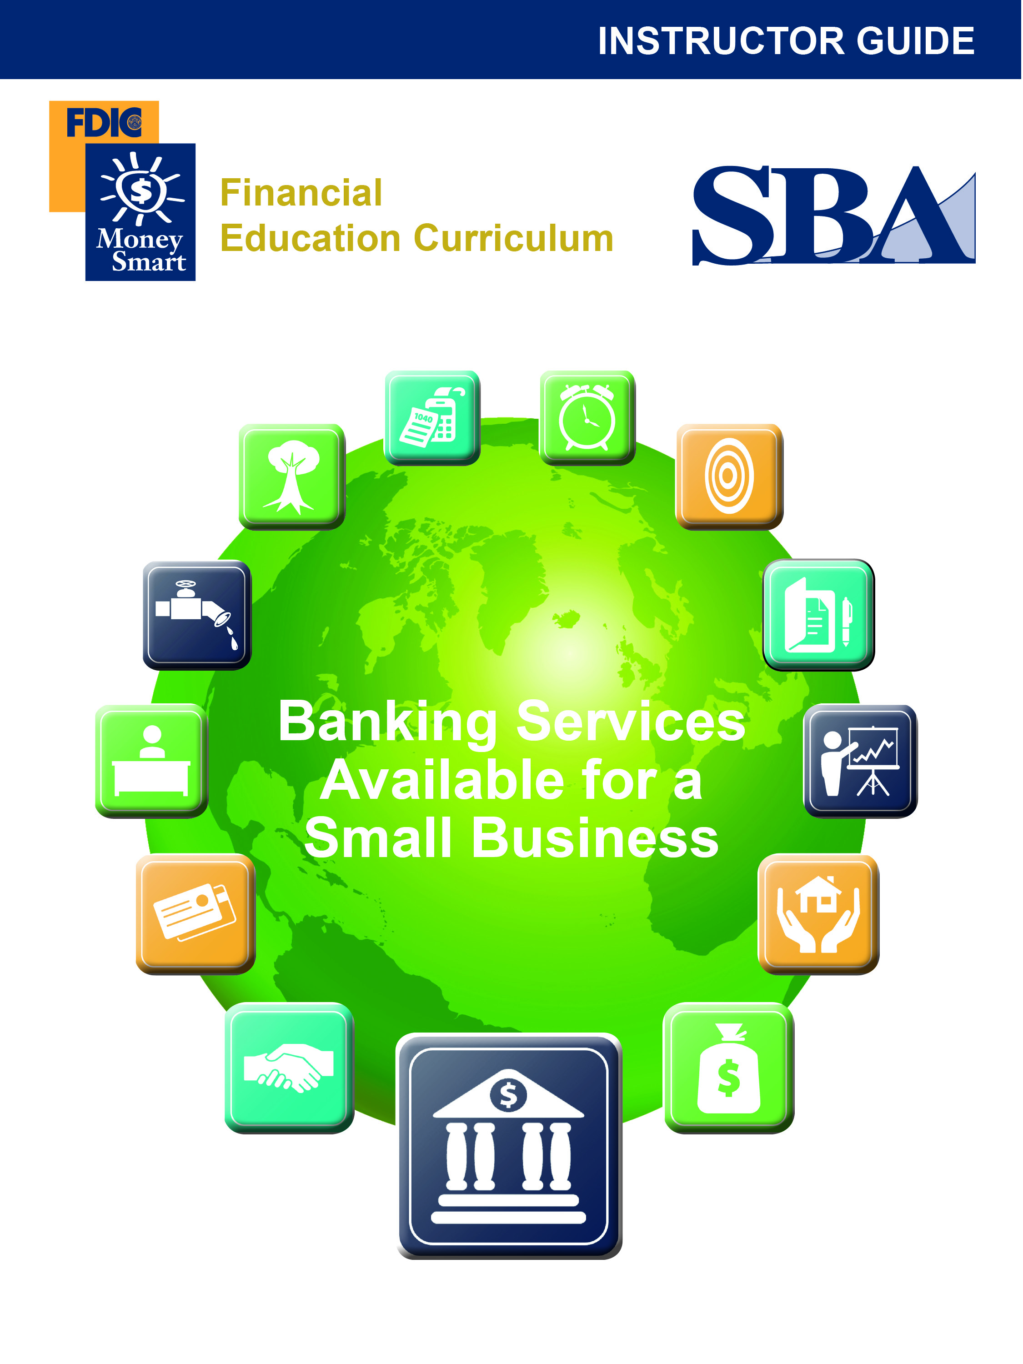

Table of Contents
Getting Started 3
Training Overview 4
Welcome, Agenda, Learning Objectives, What Do You Know? 7
Business Banking Fundamentals 13
Additional Banking Services 26
Commercial Lending 31
Building Your Banking Relationship 37
Conclusion 37
Sample Post-Test 40
Evaluation Form 42

DISCLAIMER

These training materials are intended as general guidance only and may or may not apply to a particular situation based on the circumstances. The materials do not create any legal rights or impose any legally binding requirements or obligations on the Federal Deposit Insurance Corporation (FDIC) and U.S. Small Business Administration (SBA). The FDIC and SBA make no claims or guarantees regarding the accuracy or timeliness of this information and material.

The content of this training material is not designed or intended to provide authoritative financial, accounting, investment, legal or other professional advice which may be reasonably relied on by its readers. If expert assistance in any of these areas is required, the services of a qualified professional should be sought.

Reference to any specific commercial product, process, or service by trade name, trademark, manufacture, or otherwise does not constitute an endorsement, a recommendation, or a preference by the FDIC and SBA or the United States government.

Getting Started
Here are ideas to help you plan and present engaging and productive sessions:

- Effective use of PowerPoint. Use the slides to introduce key concepts only—(they are provided to support and enhance your presentation, they are not the presentation.) Avoid reading slides to the learners. Add your perspective. The learners will appreciate interesting examples and brief anecdotes that make the concepts come alive.
- Introductions. Introductions allow you to “break the ice,” create active instructor–participant dialogue, and set the tone for the session. They also provide strong indicators of the experience levels of your learners as business owners.
- Diversity of learner needs. Assume that some learners are just getting started (Group A) while others have already gone down the path to business ownership (Group B). Where appropriate, Group A and Group B options are provided to allow you to anticipate and address the diverse needs of learner groups.
- Agenda and ground rules. Providing an agenda and ground rules helps participants understand how the training will be conducted.
- Expectations. Discussing expectations gives participants the opportunity to tell you what they hope to learn from the training.
- Objectives. Establishing objectives helps participants place the information to be learned in the proper context and ensures that the content is consistent with their expectations.
- Participant Workbook format and contents. The workbook serves to keep participants on track with the presentation. Several worksheets help them apply key concepts to their own specific contexts.
- Pre-Test. This helps determine what the participants already know or do not know so you can customize the presentation accordingly.
- Discussion points. Having discussion points helps participants reinforce learning.
- Post-Test. This can help gauge how well participants learned the content, giving you an indication of what content to review, if any, and what additional materials participants may want to review on their own.
- Parking Lot Flipchart/Chart Paper. This option is helpful if you are asked complicated questions that you do not have time to answer. Instead of answering, agree to answer at a later time. Then “park” the questions on a flipchart pad or chart paper and make arrangements to follow up with the participant(s) after the module.
- Breaks. No formal breaks are recommended. Encourage participants to take rest room breaks if they need them.

Icons Guide
PG | - Refer participants to the Participant Guide (PG) to locate information, descriptions, or relevant worksheets.
Group Discussion | - Engage the group in a conversation about the topic.
Assess | - Assess participant comprehension or previous experience with the topic by asking them to take a quiz.
? | - Ask a “high gain” question to check comprehension, or present a problem such as “What would you do if this was your business?

Training Overview

Purpose
The Banking Services module provides an overview of banking services available to small business owners. It is designed to help participants to understand which banking products and services can benefit their business.

This Instructor Guide is the key document for this class. Please read it thoroughly. We provide plenty of white space for you to add notes and examples from your own experience. Please also review the related PowerPoint slides and Participant Guide in detail. These documents contain information or visuals you will reference during the class.

Preparing for Class
Each participant will require a Participant Guide (ideally printed two-sided). Participants do not need copies of the slides. Before printing the guides, consider adding local information to the For More Information section. In the space provided, list local resources that offer technical assistance or financing options to small businesses.

Learning Objectives

After completing this class, the participants will be able to:

- Identify the banking services commonly available to a small business and explain how these services work.
- Identify the advantages and disadvantages of each of the banking services.
- Explain how small business owners decide which banking services are best for their business.
- Define several forms of deposit insurance.
- Describe some benefits of building effective long-term relationships with a banker or lender.
- Describe the role of a personal credit score in the lending process.
- Explain the benefits of separating business and personal bank transactions.

Presentation Time
Each topic has an approximate completion time. Use the suggested times to personalize the training based on your participants’ needs and the given time period. Allow extra time for discussion and questions when teaching larger groups.

The Module at a Glance
Timing (in minutes) | Topic | Instructor Comments/Notes
10 | Welcome, Pre-Test, Agenda, and Learning Objectives
20 | Business Banking Fundamentals  - Discussion Point 1: Banking Needs
20 | Additional Banking Services  - Discussion Point 2: Banking Service Needs
20 | Improve Your Chances of Getting a Loan
5 | Wealth Management and Retirement Planning
5 | Conclusion, Key Points to Remember
10 | Summary, Post-Test, Evaluation
90 Total

Materials and Equipment
The materials and equipment needed to present this training are:
- Instructor Guide
- Participant Guide
- PowerPoint Slide Deck
- Audiovisual equipment (such as a computer with Microsoft Office PowerPoint, overhead projector, and microphone, if appropriate)

Presentation |  |  | Instructors Notes
10 minutes |  |  | Welcome, Agenda, Learning Objectives, What Do You Know?
Slide 1  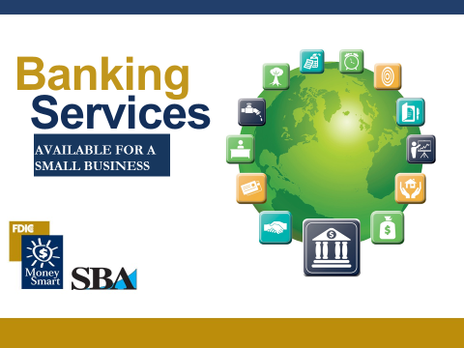 |  | Welcome to Banking Services. By taking this class, you are taking an important step to building a better business.  My name is ______________ (briefly introduce yourself).
Slide 2  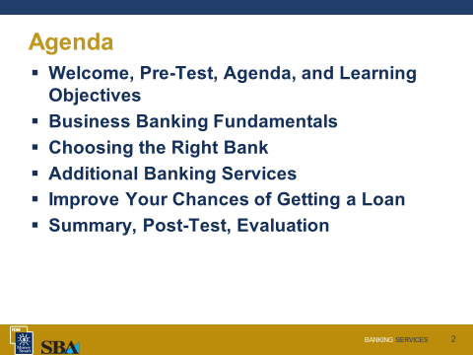 |  |  | Agenda  We have a very full agenda today. We will not have time to cover everything. Fortunately your participant guide is very detailed. We encourage you to read it on your own time.
Slides 3 and 4  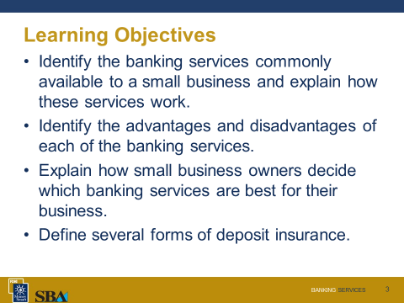  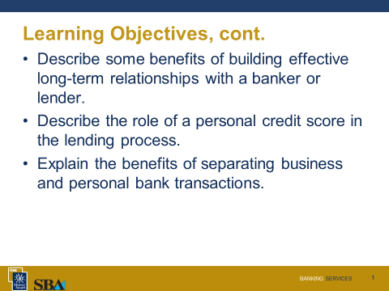 |  |  | Learning Objectives  Briefly review the objectives listed on the slides.  - Identify the banking services commonly available to a small business and explain how these services work.  - Identify the advantages and disadvantages of each banking service.  - Explain how small business owners decide which banking services are best for their business.  - Define several forms of deposit insurance.  Objectives, cont.  - Describe some benefits of building effective long-term relationships with a banker or lender.  - Describe the role of a personal credit score in the lending process.  - Explain the benefits of separating business and personal bank transactions.
PG |  |  | Participant Guide  Each of you has a copy of the Banking Services Participant Guide. It contains information and discussion points to help you learn the material. We do not have enough time to go over everything in the guide. Make some time to review it on your own. It contains a lot of helpful information. Also make sure to check out the For More Information section in the back which lists many valuable resources.
Slide 5  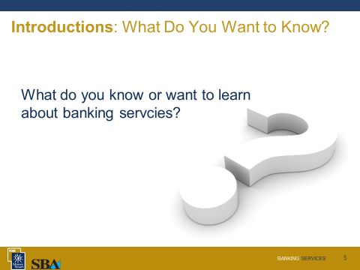  Use the What Do You Know? form and/or the Pre-Test to gauge participants’ prior knowledge of the content and customize your presentation, focusing on content with which they are least familiar.  Assess | What Do You Know?  Before we begin, we will see what you know about banking services for a small business.  [If using the What Do You Know? form]  The What Do You Know? form on page 4 of your participant guide lets you compare how much you know before the training and how much you learned after the training. Please take a few minutes now to complete the “Before the Training” column. Which statements did you answer with “disagree” or “strongly disagree”?  - If time is limited, make sure you cover these content areas.  - A sample What Do You Know form is provided on the following page of this instructor guide.  We will complete the second column when we finish the training.  [If using the Pre-Test]  Take a few minutes to complete the Pre-Test beginning on page 5 of your participant guide. Which questions were you unsure of or unable to answer?  - Note: If time is limited, make sure you cover these content areas.  - A sample Pre-Test is provided on the following pages of this instructor guide.  As we progress through the module and cover the related material, you will be able to determine whether you answered each question correctly.  Now that we know who is here and what you want to know, we will move on to a discussion of the benefits of financial management.
Sample What Do You Know? Banking Services
Instructor: _____________________________________________________ Date: ____________________

This form will allow you and your instructors to see what you know about business banking services both before and after the training. Read each statement below. Please circle the number that shows how much you agree with each statement.

 | Before Training |  |  |  |  |  | After Training
 | Strongly Disagree |  | Disagree |  | Agree | Strongly Agree | Strongly Disagree | Disagree | Agree | Strongly Agree
- I can identify the banking services that are commonly available to a small business. | 1 | 2 |  | 3 |  | 4 | 1 | 2 | 3 | 4
- I can explain how these banking services work. | 1 | 2 |  | 3 |  | 4 | 1 | 2 | 3 | 4
- I can identify the advantages and disadvantages of each of the banking services. | 1 | 2 |  | 3 |  | 4 | 1 | 2 | 3 | 4
- I can explain how small business owners decide which banking services are best for their business. | 1 | 2 |  | 3 |  | 4 | 1 | 2 | 3 | 4
- I can explain several forms of deposit insurance. | 1 | 2 |  | 3 |  | 4 | 1 | 2 | 3 | 4
- I can describe some benefits of building effective long-term relationships with a banker or lender. | 1 | 2 |  | 3 |  | 4 | 1 | 2 | 3 | 4
- I can describe the role of a personal credit score in the lending process. | 1 | 2 |  | 3 |  | 4 | 1 | 2 | 3 | 4
- I can explain the benefits of separating business and personal bank transactions. | 1 | 2 |  | 3 |  | 4 | 1 | 2 | 3 | 4

Sample Pre- and Post-Test
- The correct answers are in bold below.
Test your knowledge of banking services before you go through the training.

- Which of the following are the basic business checking account types? Select all that apply.
  - Small business account
  - Savings account
  - Commercial account
  - Investment account

- Which of the following best characterizes a “zero balance account”?
  - Account is maintained with no funds until checks are written
  - A new account
  - A closed account
  - Account with funds that are withdrawn until no funds remain

- Purchases and receipts for your business should be kept separate from your personal ones.
  - True
  - False

- Which of the following is true about a Certificate of Deposit (CD)?
  - Typically it pays a higher interest rate than a savings account
  - A one-time withdrawal is allowed on a penalty-free CD
  - Account maturity term is usually 72 months
  - Both a. and b.
  - All three: a., b., and c.

- CDs are sometimes used as loan collateral.
  - True
  - False

- Which of the following is a common advantage of online banking?
  - Normally information is updated frequently so activity is viewable within minutes
  - Check images may be available for viewing
  - Eliminates research charges for check copies and past statements
  - Both b. and c.
  - All three: a., b., and c.

- If a business becomes a victim of online theft, there is a chance that the money may not be recoverable and the bank may not be responsible for the loss.
  - True
  - False

- Deposit accounts should be reconciled at least ________________________.
  - Daily
  - Weekly
  - Monthly
  - Yearly

- Only an account signer is authorized to conduct transactions with a debit card.
  - True
  - False

- With a term loan, the purpose of the loan will typically determine the length of the financing.
  - True
  - False

Instructor Notes |  | Presentation
20 minutes | Business Banking Fundamentals
Slide 6  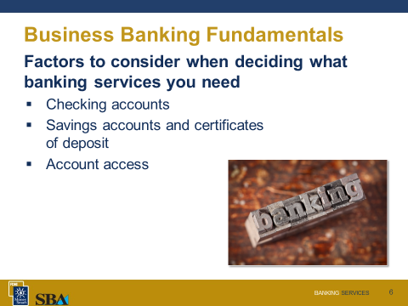 | There are many services available to the consumer and small business owner. With technological advances, these services are constantly changing. Before we talk about the types of bank accounts listed on the screen, let us discuss how to choose the right bank.  What do you need?  To help with the process of identifying your banking needs, consider the following questions:  - Do I need to regularly pay employees or vendors?  - Do my customers generally pay me via check, credit card, electronic transfer, or in cash?  - Do I want to be able to download statements and transactions into a software program?  - Will I need to make deposits after banking hours? If so, do I need a night depository bag with locks or a remote deposit scanner?  - What are my cash needs?  - Does my business need a lot of change or small bills? What are the fees to buy cash from the bank?  - What are my loan needs?  - Do I need start-up funds, an SBA loan guarantee, a line of credit, or a minimum business loan to build credit?  - How helpful would it be to have a banker who understands any unique aspects of my industry or profession?
Slide 7  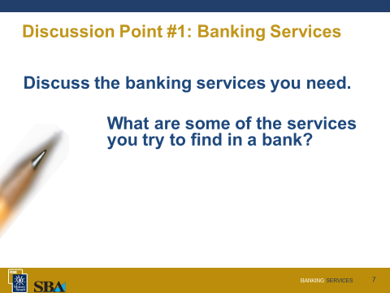  Group Discussion | Discussion Point #1: Banking Services  Discuss the banking services you need.  What are some of the services you will try to find in a bank?  If you do not currently have a bank for your small business, what do you plan to look for as you are searching for a bank?  - Validate participants’ answers.
PG | Please refer to your Participant Guide for detailed information.
Slide 8  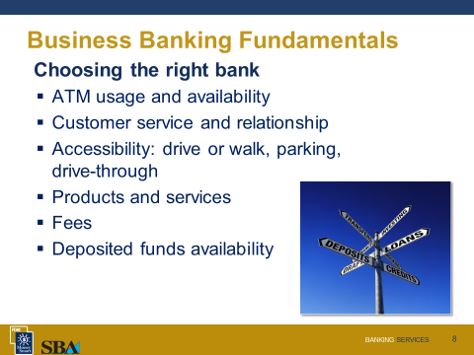 | Choosing the Right Bank  Consider your unique needs and preferences when choosing the right bank and bank accounts. For example, perhaps you need to make deposits into your account through an ATM after normal banking hours. Most banks will list their core products and minimum balance requirements on their websites. Call your bank or a few in your area and ask for an appointment to meet with the branch manager, a bank officer, or a commercial lender. Discuss the needs of your business and request their input. They can direct you to the right services to meet your needs. Here are a few factors to consider as you choose what is best for your needs.  What is the bank’s customer service like?  Perhaps you already have a relationship with this bank or know someone who is pleased with the bank’s customer service. A good relationship with a key person at your bank can help you establish or increase credit, save you money in fees, and enhance your business opportunities through taking advantage of the banker’s extensive personal contacts. Establish a list of key people with whom you can discuss banking services such as deposit, loan, online, and investment services. Ask if the institution has a track record of catering to small businesses and how many small firms it serves. Find out if it has a special unit dedicated exclusively to small business needs. Ask yourself if the representative who meets with you seems genuinely interested in your business and the market you serve. Ask other small business owners about institutions they recommend.  How accessible is the bank you plan to visit?  Businesses spend hours or days going to the bank each year so choose a bank that is accessible for you. Consider whether the bank needs to be within walking distance. If you’ll be driving to the bank from a home-based business, determine whether parking is plentiful. If you will be regularly carrying cash deposits into the bank, be sure you would be comfortable walking from where you would park into the branch. If you plan to use the drive-through, ask the bank if there are any restrictions on transactions that can be made at the drive-through window.  Do the banking services meet my needs and what are the costs?  Evaluate the services of each bank you are considering by reviewing the bank’s product brochures, funds availability disclosures, and fee sheets. Compare these to your business needs. Find out how you may be able to get fees waived, perhaps such as by consolidating multiple accounts at the bank.  You should also find out how long it will take before you can access your deposited funds because waiting for checks to clear may impede your cash flow. Writing a check when you do not have funds available to cover the deposit will likely lead to costly charges.  Is the bank FDIC-insured?  Take time to verify that the bank is FDIC-insured and understand your coverage limits. FDIC insurance covers all deposit accounts, including checking and savings accounts, money market deposit accounts and certificates of deposit. The standard insurance amount is $250,000 per depositor, per insured bank, for each account ownership category. FDIC offers interactive deposit insurance estimator tools at www.fdic.gov. The National Credit Union Administration (NCUA) protects any deposits you may have in a federally insured credit union just as the FDIC protects your insured deposits in a bank deposit account.

Is the bank FDIC-insured?
Take time to verify that the bank is FDIC-insured and understand your coverage limits. FDIC insurance covers all deposit accounts, including checking and savings accounts, money market deposit accounts and certificates of deposit. The standard insurance amount is $250,000 per depositor, per insured bank, for each account ownership category. FDIC offers interactive deposit insurance estimator tools at www.fdic.gov. The National Credit Union Administration (NCUA) protects any deposits you may have in a federally insured credit union just as the FDIC protects your insured deposits in a bank deposit account.

More detailed information about FDIC Insurance coverage is provided in the Participant Guide.
Slide 9  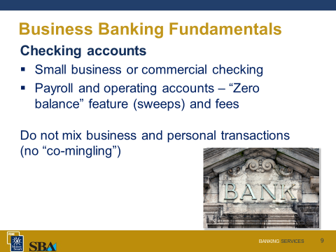 | Checking Accounts  Banks may have different names for their checking accounts and the checking account products offered and their features differ. Ask your bank representative to explain the account types to be certain you select the proper checking account product(s) to meet the needs of your business.  Small Business Checking Account  A small business checking account will generally allow fewer fee-free transactions, including deposits and checks, on a monthly basis. This account usually has a lower minimum balance requirement than other business checking accounts.  Commercial Checking Account  A commercial checking account is geared for a higher volume of transactions and has a larger minimum balance requirement. To assess fees, commercial checking accounts are often set on an analysis schedule. Each month the system monitors the account for balances and transactions. The bank assesses charges at the end of the statement cycle based on the number of checks, deposits, number of checks in the deposits, cash purchased from the bank, remote capture scanner rent, and other fees listed on the bank’s fee schedule. Also at the end of the statement cycle, the bank may pay you interest or give you an earnings credit to offset fees.  Compare the checking account packages offered by different banks to find what’s best for you.  Once you open up your checking account, know the rules governing checks, as they depend largely on the law of your state. For example, many states have adopted the Uniform Commercial Code, which generally holds the bank — not the account owner — liable if someone forges a signature on a check. But that doesn’t mean you could never be liable for losses. In general, you can protect yourself from liability by securing your checks, thinking carefully about who in your business has access to blank checks, reviewing your statements when they arrive (or more frequently via online access), and reporting any problems to your bank immediately. Your deposit account agreement may include more information about your liability for forged checks, so read it closely. And for legal advice, ask an attorney.
 | Do Not Mix Business and Personal Transactions
Slide 10  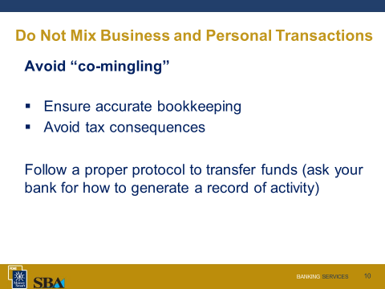 | Keep your business and personal transactions in separate accounts. Do not use personal accounts to hold business funds. Keeping separate savings, checking, and credit card accounts is necessary for accurate record keeping, will help you at tax time, and may even be required depending on your corporate structure. For bookkeeping purposes, it is essential that you keep transaction separate.  More information about the risks of “co-mingling” is detailed in your participant guide.
Slide 11  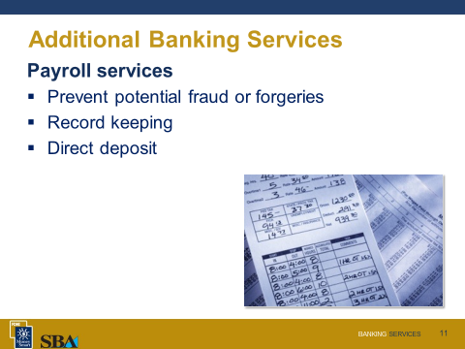 | Payroll Services  Bank payroll services can help cut down on the number of checks issued and the potential for fraudulent or forged payroll checks. These services permit entry of payroll, retirement, and worker’s compensation insurance payments, as well as federal and state taxes. Numerous reports can be generated for your records. The reports can include summaries for each employee, the entire payroll, or a history with date ranges and data filters.  Payroll can be direct-deposited to the employee’s account. If your business has employees who do not have a bank checking or savings account, talk to your bank. Many banks will be happy to work with you to provide direct deposit for these employees. For example, they may be willing to meet with your employees to open free or low-cost checking accounts. Many banks have products to meet the needs of those who need a second chance checking account. These accounts are opened for individuals whose names appear on a check reporting agency report for a former problem account.
Slide 12  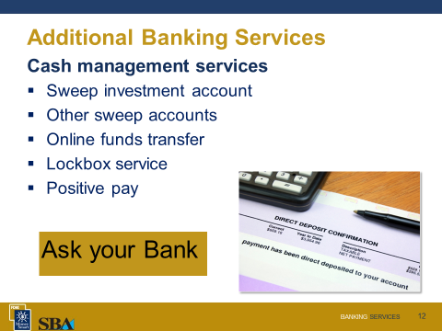 | Cash Management  Many businesses find it helpful to have an operating account and a payroll account. To ease the burden of conducting transfers to a payroll account, most banks can set up a sweep feature on your operating account that links to your payroll account. This is known as a “zero balance” feature. With this feature, you only make deposits to your operating account and you only write payroll checks out of the payroll account. As each paycheck is presented to the bank, the system totals the checks and moves exactly that amount to the payroll account from the operating account. This helps to prevent fraud. By monitoring the sweeps, you would quickly know if amounts were greater than your payroll. This could be an indication of an error or highlight an altered or forged check. Remember, the payroll account will remain at zero at the end of each day’s processing. Be sure to ask your bank representative if an account with a “zero balance” feature will be charged fees. If you prefer to make transfers to payroll yourself, consider establishing online access.  A sweep investment account is used to earn interest on larger balances. The agreement sets up two accounts, with a required minimum balance in the primary account. This balance is determined by the bank, based on reserves. All funds are deposited into the main account, but amounts over the minimum are swept daily into the overnight investment of securities. These investment securities are not covered by FDIC insurance. Checking accounts may be coded to sweep funds from a line of credit or to make payments to the line or business loan.  For more information, ask your bank for a list of its cash management services and related fees.
Slide 13  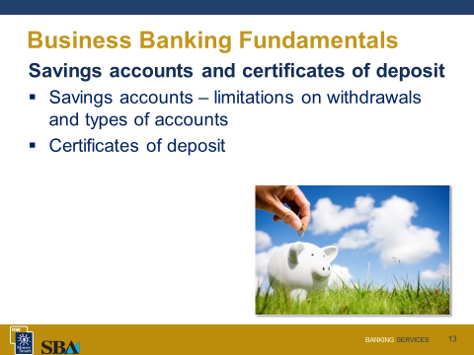 | Savings Accounts and Certificates of Deposit  Having a savings account helps to build a cushion for unexpected needs. Setting aside money also shows your lender that you are reserving cash.  Savings Accounts  Savings accounts have limitations on the number of withdrawals permitted each month. Ask the bank representative to explain the available types of savings accounts, any fees, and the rules that apply to how you can use the account. For example, repeatedly exceeding the maximum number of withdrawals during a monthly cycle may require the bank to close the account or necessitate moving the funds to another type of account.  Certificates of Deposit  With the traditional FDIC-insured certificate of deposit (CD), you agree to keep the money in an account for a few weeks to several years. In return, the bank agrees to pay you a higher interest rate than you would receive from a checking or savings account. If you need to withdraw the money before the CD matures, you would pay a penalty. However, the traditional CD now is only one of the choices. Now you may be able to add money to the CD, switch to a higher interest rate or withdraw money early without a penalty. Most banks will require you to deposit at least $500 into a new CD, but some will allow you to open one with a smaller deposit.  The rates, terms, and features for CDs may vary significantly from bank to bank. It pays to shop around.  CDs are sometimes used as loan collateral or held for bank-issued letters of credit. If you need to build a credit history for your business, check with your bank whether a CD-secured loan is an option.
Slide 14  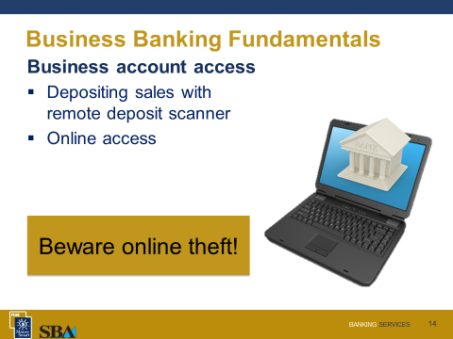 | Account Access  Online banking allows businesses to conduct nearly every facet of their banking business without entering the bank. However, authorization, viewing, and transaction limitations apply. Banks set up access and issue keys for logins after the completion of authorization forms. The authorization process may vary slightly between banks. You may want to set up levels of access for your employees to view or transact business, if you decide to allow your employees to use online banking.  One advantage of banking online is that information is normally updated throughout the day, so you can view account activity within minutes of the activity. Another advantage is that the front and back images of checks, and previous statements are often available. This eliminates charges for services to provide copies of lost checks and past statements.  When banking online, you want to take steps to avoid fraud. If your business becomes a victim of online theft, there is a chance that the money may not be recoverable and the bank may not be responsible for the loss. You should partner with your bank to create and maintain secure banking practices.  Direct Deposit, ACH debit and credit processing, and wire transfers  Direct deposit, ACH debit and credit processing, and wire transfers provide for quick online transfer of funds. You can generate these from your office for purchases, transfers to other businesses, and to pay employees.  Lockbox Services  Lockbox services permit you to focus on doing business while payments customers mail to you are processed by the bank. Your customers will send checks or other payments to a special address that the bank assigns to your business. The bank will process and credit them to your account and provide a record to you.  Remote Deposit Capture (RDC)  If you do not feel like walking or driving to your bank to deposit a check or if you would rather not spend the time and the money to mail it in, you have an option at some banks: the ability to "deposit" paper checks electronically. You will need a scanner (to capture an image of the check) and a personal computer (to securely transmit the image online), or a cell phone equipped with a digital camera that can do similar duty. Banks may also issue a scanner based on the volume of checks the business deposits. High speed scanners help to process large numbers of checks, but for businesses processing twenty checks a day, the slower model may be more appropriate.  Known in the banking and technology industries as "remote deposit capture" or RDC, this service is mostly marketed to small businesses that typically are paid by check and want to be able to quickly deposit those payments. RDC allows you quicker access to the funds because checks deposited over the Internet are generally available in one or two business days as opposed to five business days for regular paper checks.
Slide 15  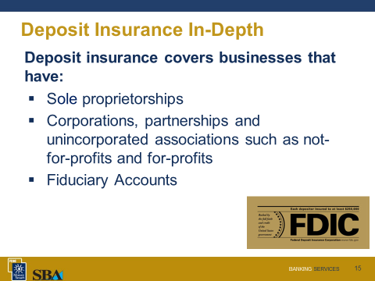  Briefly describe the key principles of deposit insurance as listed on the slide. Refer to the Participant Guide for detailed information. | Deposit Insurance In-Depth  Here are some details of FDIC deposit insurance coverage that may pertain to your business.  Basic Insurance Principles:  Deposit insurance coverage is per depositor. A depositor may be any person (does not have to be a citizen or even a resident of the United States) or any entity (Businesses, Organizations, Governmental entities).  Deposits maintained in separate FDIC-insured banks are separately insured. Deposits maintained in separate branches of the same FDIC-insured bank are NOT separately insured.  The FDIC covers Checking accounts, Negotiable Order of Withdrawal (NOW) accounts, Savings accounts, Money Market Deposit Accounts (MMDAs), Time deposits such as certificates of deposit (CDs), Cashier's checks, money orders, and other official items issued by a bank.  Deposit Insurance for Different Business Organizations  Organized as a Sole Proprietorship  A sole proprietorship account includes funds collected by an individual conducting business using a business name. As an example, “John Smith (the owner of the account) Doing Business As (often abbreviated as “DBA”) John’s Fishing Bait.” An account opened in the name of a sole proprietorship is insured by the FDIC under the Single account ownership category. The Single account ownership category includes accounts titled under an individual’s name with no beneficiaries designated on the account.  In the unlikely event of your bank’s failure, the FDIC would add together the funds in your sole proprietorship deposit account with any other Single accounts owned by you at the same bank and insure the combined total balance for up to $250,000. If the business account is owned by two persons where each owner has equal withdrawal rights to the funds in the account, then the account would be insured under the Joint Account category and insured for up to $500,000.  Organized as a Corporation, Partnership, or Unincorporated Association  Deposits owned by corporations, partnerships, and unincorporated associations, including for-profit and not-for-profit organizations, are insured under the same ownership category. These are considered a separate legal entity from the owner, and they are insured separately from the owner’s personal deposits. All deposits owned by the same corporation, partnership, or unincorporated association at the same bank are combined and insured up to $250,000.  To qualify for insurance coverage under this ownership category, a corporation, partnership or unincorporated association must be engaged in an "independent activity," meaning that the entity is operated primarily for some purpose other than to increase deposit insurance coverage.  Deposit Insurance for Fiduciary Accounts  If you are a business that handles other people’s money, either as a broker, agent, realtor, firm, or other business transaction, then you are acting with fiduciary powers.  Fiduciary Accounts, in their simplest form, are bank deposit accounts in which the funds are owned by one individual or entity or group of individuals or entities and managed by a fiduciary. The most common Fiduciary Accounts for small businesses include:  - Escrow Accounts (real estate transaction accounts)  - Agency Accounts (broker accounts, business or personal trusts)  - Property Management Accounts (rent, security deposits)  - IOLTAs or similar (court settlements, estates)  When funds are deposited by a fiduciary or custodian on behalf of one or more actual owners of the funds, the FDIC will insure the funds as if the actual owners had established the deposit in the bank themselves. FDIC describes this as “pass-through” deposit insurance coverage.  The key to establishing pass-through deposit insurance coverage is the clear indication that funds are being held in an agency, custodial, or fiduciary capacity. It is important to use language such as but not limited to “FBO” (For the benefit of others), “As agent for others,” or “As custodian for others.”  A fiduciary or custodian should not mix deposit funds into accounts that may hold your corporate owned funds. To establish the existence of pass-through insurance coverage, either the bank records or the fiduciary’s records need to be able to provide the FDIC with each principal owner’s name as well as their ownership interest in the deposit account. Typically it is the fiduciary who maintains such specific information. It is also important that the deposit terms (i.e. the interest rate and maturity date) for accounts opened at the bank match the terms the fiduciary agent promised to the customer. If they do not match, then the fiduciary agent might be deemed to be the legal owner of the funds.  Retirement Accounts and other Employee Benefit Accounts  At some point during your small business activities you may want to establish retirement account options for yourself and/or your employees.  Employee benefit accounts established for employees include Individual Retirement Accounts (IRAs), defined benefit pension plans, profit sharing plans, Health Savings Accounts, 401K plans, and cafeteria plans. These plans will almost always be insured separately from the accounts that belong to the business itself.
20 Minutes | Additional Banking Services
Slide 16  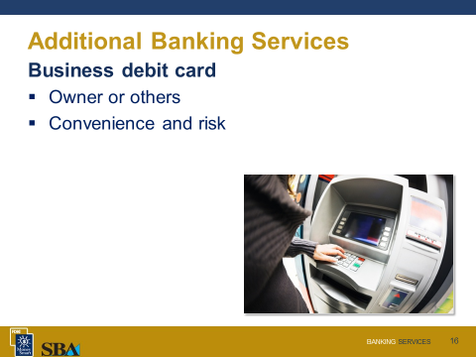 | Business Debit Cards  The business debit card allows your business to make online purchases or point of sale purchases without the use of credit. This card also allows for cash withdrawals at ATMs.  Debit cards are most often issued in the name of the owner of the business. Only an account signer is authorized to conduct debit transactions on the account. As the owner, you may have additional signers on the account and want these people to have a card. Perhaps your employees are going to travel or have a need to purchase office supplies. Discuss the card and its intended use with a bank representative to determine if your plan is feasible. The bank may suggest an alternative, such as a preloaded card from its credit card processor.  If you decide to have a card issued, be aware of the risks. Using caution with debit cards will protect you from fraud and losses. A dishonest employee could use the card for personal purchases or obtain the maximum allowable amount of cash each day through an ATM. Even greater losses could take place over a weekend. If an employee leaves your employment, it is up to you to get the card back or cancel it. Federal law provides many protections to consumer holders of debit cards — such as limitations on liability if the card is lost or stolen — but not to business accountholders. While business credit cards can have some of these protections, business debit cards have none. Because federal law doesn’t protect business debit cards, it’s very important to understand the terms of your bank account agreement regarding liability for unauthorized transactions. State laws regarding commercial transactions may provide some protections, so consider asking an attorney for further information.  If you lose or misplace the card, notify your bank immediately. And, review the transactions on your account statement as soon as it arrives and immediately report to the bank any possible errors or fraudulent activity.  Bank debit cards have a daily limit set for point-of-sale (POS) purchases, cash withdrawals, and an overall limit. These amounts may be adjusted by the bank, but only to a degree. The card processing company has limits that cannot be changed by the business owner. Most banks will assist you in making a larger purchase, by raising the limit for the time needed to make the purchase. You will need to contact the bank to request this.
Slide 17  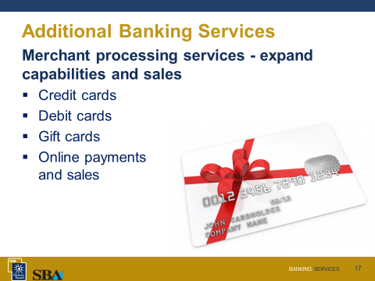 | Merchant Services – Expand Capabilities and Sales  Your sales could increase by accepting consumer credit cards and many banks offer merchant processing services that allow your business to accept credit and debit cards. These services may include point-of-sale card reader terminals, marketing support, online tools, and gift or prepaid cards that can be loaded at your locations. Gift or prepaid cards function like electronic gift certificates that can provide advance sales and generate income during the holidays and on special occasions. If you are providing wholesale products, then merchant services may be able to establish an online system to receive payments from buyers, which can decrease the time from billing to receipt and improve cash flow.
Slide 18  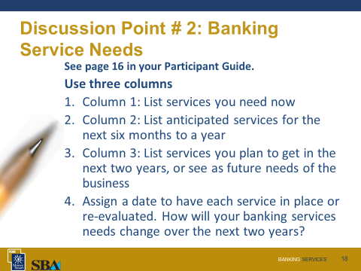 | Discussion Point #2: Banking Service Needs
PG | Please turn to page 16 in your participant guide to locate a table where you can capture your banking service needs. In the first column list the services you need now. List banking services you anticipate in the next six months to a year in the second column. In the third, list services you plan to obtain in the next two years or services you think may meet future needs. Assign a date to each representing when you need to have the service in place or when you will need to re-evaluate.  How will your banking services needs change over the next two years?
Slide 19  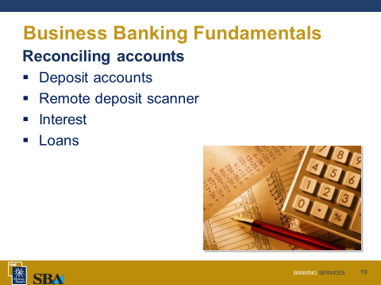 | Reconciling Accounts  Deposit accounts should be reconciled when you receive your monthly statement, but with online access you may want to review your account activity even more frequently – perhaps daily.  Your bank statement should contain directions on reconciling the account. If you are having difficulty balancing the statement to your records or find discrepancies, contact your bank. If you find an error in your bank statement, contact the bank as soon as possible.  Here are a few tips for reconciling your accounts:  - The amount encoded on the bottom right of a check should be the amount for which the check was written.  - Retain remote scanner software reports.  - Reconcile the interest on your business loan accounting records to the applied rate each month to save time at year end. Check principal balances as well.  Reconciling your accounts may mean investing time each month but is worthwhile to avoid the frustration caused by errors, fraud, or the need for research months later.
Slide 20  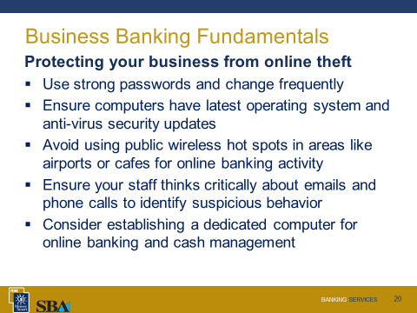  PG | Avoiding Fraud  Even if you do not plan to use online banking, you need to be vigilant to avoid fraud and scams. Remember, unlike consumer electronic payments that are generally protected by federal consumer protection laws, the liability for business electronic payments are governed by contract and state law, which could leave your business liable for online theft.  One very important step you can take to protect your business is to regularly monitor your account to look out for suspicious transactions. Report any questionable transactions to your bank as soon as possible. The faster a fraudulent transaction is identified, the better the chance that the any lost funds can be recovered.  It is important that you take some basic “safe computing” measures to stay safe online in order to avoid potential losses associated with online fraud.  Cyber-thieves have been using increasingly sophisticated tactics to steal business banking credentials and/or “hijack” browser sessions in order to access and attempt to steal funds from business accounts. This tactic known as “corporate account take over” has resulted in some businesses being subject to huge losses along with several high-profile lawsuits. Thankfully, there are some basic steps you can take to mitigate the possibility of becoming a victim and protect your business.  - Be on guard against inside jobs. This includes employee theft or misuse of cash, merchandise or equipment as well as fraud. Minimize risks through steps such as pre-employment background checks, automated inventory tracking systems, audits, and clearly outlined policies for personal use of computers and other business equipment. Also, carefully select who handles revenue from customers, pays the bills and reviews account statements. And, ensure that there are procedures in place to detect and deter fraud.  - Ensure that all everyone establishes “strong” unpredictable passwords that are updated frequently. Avoid using common names that may be identified by clever cyber-thieves. Consult your bank for information on best practices for internet banking authentication.  - Make sure your computer has the latest operating system and anti-virus security updates. Many of the most high-profile losses to businesses have involved known vulnerabilities that could have been prevented by using updated software.  - If your business operates “on the go” and you need to manage your bank relationship remotely, avoid using pubic wireless hot spots in areas such as airports and cafes when conducting online banking activity. These public internet connections might be compromised.  - Train and educate your staff to “think critically” about phone calls and emails that relate to your business banking relationship. Many online thefts are multi-faceted and sometimes begin with seemingly benign “social engineering” tactics. A thief will use these tactics to discover individual pieces of information that when combined may provide enough information to conduct an online theft. Beware of correspondence (such as phone calls, emails, and letters) from individuals claiming to be your bank seeking to verify your account information or warning you to update your credentials.  - Watch out for fraudulent transactions and bills. Scams can range from consumer payments with a worthless check or a fake credit or debit card to fraudulent returns of merchandise. Be sure you have insurance to protect against risks.  - If possible, consider establishing a dedicated computer for conducting online banking and cash management activity. Using a dedicated computer avoids the risk of computer viruses and malware that can be inadvertently downloaded with general internet use.  Positive Pay and Debit Block Services  Positive pay services, available at many banks, help protect your account from being subject to ACH and check fraud. You provide the bank with a list of expected ACH transactions and checks, along with the expected amounts and dates. Then, as items are processed they are matched to the list. Mismatches will generate a notice to your office for payment approval. A debit block is another service offered by many banks that allow you to control whether or not an ACH debit transaction may be made against your business account. If your business plans to use your account primarily for paying employees or vendors (credits), and writing checks, there may be no need to allow business debits to your account through the ACH system.
Slide 21  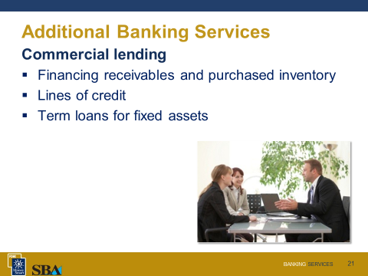  PG | Commercial Lending  Small business owners typically need to borrow money to buy equipment, pay suppliers and employees, and otherwise finance their operations.  Understand the different types of financing. For most small businesses, operations can be financed in three key ways (not including investments or loans from family and friends):  - Personal lines of credit, such as credit cards (either an owner’s personal card or a business card guaranteed by the owner) or home equity lines of credit (the small business owner’s home serves as the collateral) are commonly used, but they have disadvantages. Small business owners willing to put their personal credit record on the line may find a credit card convenient, but it can be an expensive financing tool. Owners using a credit card also can quickly find themselves taking on debt that cannot reasonably be supported by projected revenues from the business. The significant problem with home equity lines is the potential to lose your home if you are unable to repay funds as agreed.  - Business lines of credit permit a business to borrow up to a certain dollar amount and repay it in installments with interest over several years. Lines of credit may be a flexible way to build credit. Business owners should think carefully before borrowing on a line of credit. Consider how and when the business will generate revenue to repay the loan, and make sure you are not using a short-term financing tool to finance costly, long-term investments. Rates may also adjust. Know the index to which the rate is tied and the maximum and minimum to which the rate can adjust.  - Business term loans, which establish a set dollar amount to be repaid in installments over three or more years, are commonly recommended for purposes such as financing the purchase of equipment or a vehicle. These loans often are secured by the asset that is purchased. Term loans mean predictable payments for businesses, but unlike lines of credit, a business may have to make a new application if it needs to borrow additional funds. The purposes for the loan will generally determine the length of financing. For example, term mortgages will normally be financed longer than a term loan for equipment.  Depending on your type of business or situation, consider asking about these types of commercial financing:  - Agricultural loans  - Manufacturing loans  - Veteran and military member programs  - Exporter loans  - Distressed area loans  The financing of equipment, inventory, plant, and machinery will be recorded by the bank to protect its interests. A deed of trust is the normal instrument recorded for real estate. Uniform Commercial Code financing statements are a tool used to give public notice of the bank’s interest in other property. In some financing agreements, the bank may require that an Incidental Deed of Trust be filed on your personal residence. This Trust could be for added security or due to your personal guarantee on the loan.

Financing Receivables or Inventory
The financing of receivables and purchased inventory is repaid through cash receipts, but is evaluated on your ability to collect the receivables and on your business credit. Financing receivables and inventory helps with cash needs due to seasonal fluctuations. In general, the amount loaned on receivables and inventory will not be 100 percent. Allowances are made for accounts not collectible and for inventory that may be discounted or damaged. Your bank can tell you the maximum they will loan for this type of financing.

Slide 22  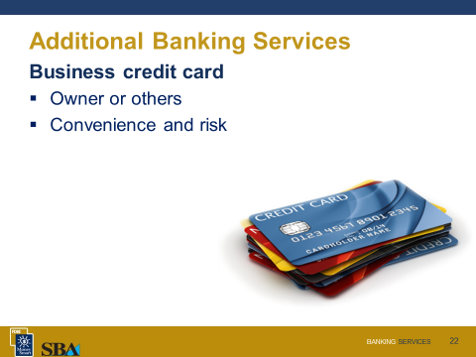  PG | Business Credit Cards  Credit cards are a convenient option because they allow you to defer payment — that is, you will be using the card issuer’s money, not your own, until you pay off the balance. Choose a credit card after carefully evaluating the interest rate, fees and terms. Depending on the card, it may also offer rewards. Pay your credit card bill on time to build your company’s credit record—and avoiding paying interest on purchases.  Additional cards can be issued for other users. These people are called “authorized users,” but they are not responsible for making credit card payments. This process may present a business risk. Be aware that your liability for unauthorized use of credit cards by a thief can be greater for business credit cards than for consumer credit cards. So before requesting a card, read the contract, and speak with the bank about your responsibilities. If you have an account that you are not using, cards should either be cancelled and destroyed, or stored in a secure place.  There may be alternatives to issuing a business credit card to your employees. Talk with your bank about employee cash and travel needs. Some solutions could be automated clearing house (ACH) credits (electronic funds transfers) to their account to cover expenses, or a card preloaded with a specific amount.
Slide 23  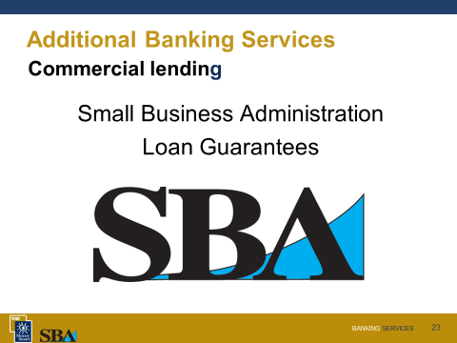 | SBA-Guaranteed Lending Programs  If you need to borrow money, your best option may be a bank loan guaranteed by the U.S. SBA. The loan is not made by the U.S. SBA, but the U.S. SBA backs a certain portion of loans to help borrowers qualify for attractive interest rates and financing. If you need a loan for less than the lender’s minimum amount, ask your bank for a referral to a lender participating in the SBA’s microloan program, which combines business coaching and technical assistance with access to loans up to $50,000 (although the average loan amount is about $13,000). Also be aware that certain borrowers, such as veterans or victims of disasters, may be eligible for special loan programs.
20 minutes | Improve Your Chances of Getting a Loan
Slide 24  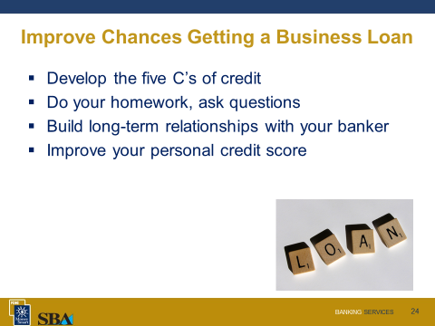  Slide 25  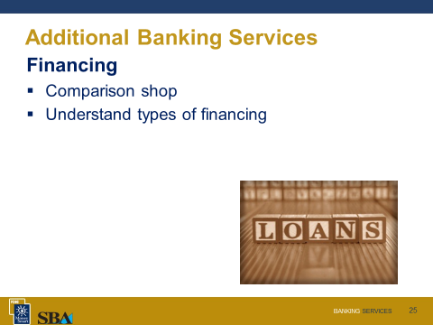  Slide 26  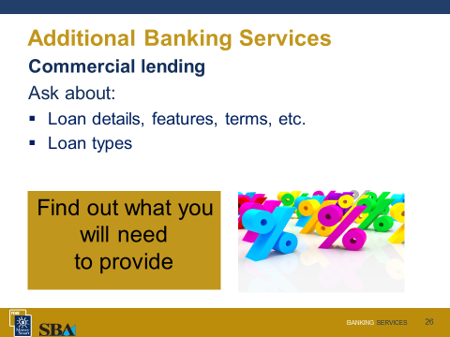 | A bank has two types of customers. Savers deposit money with a bank or lender and earn interest on their savings. Borrowers take money out in the form of loans and repay the loans with principal and interest payments.  To minimize risk and ensure full repayment of loans, banks and other lending institutions use the five C’s of credit to evaluate your ability and willingness to pay back the loan.  Your participant guide contains much more detailed information.  The Five C’s of Credit  - Capacity to repay a loan is the most critical of the factors. The lender will want to know how you intend to repay the loan.  - Capital is the money you personally invest in the business.  - Collateral is a form of security you provide the bank. Giving a bank collateral means that you pledge an asset you own – such as your home – to the bank with the agreement that it will be the repayment source in case you cannot repay the loan.  - Conditions has two meanings. The first refers to the conditions of the loan. How will you be using the money? Will it be used to expand or to purchase equipment or inventory? Conditions are also economic, locally and in your industry, which could affect your business and ability to repay the loan.  - Character refers to your personal integrity.  Remember, a lender must evaluate your ability to repay a loan based on projected cash flows (your revenues) not on the value of your collateral.  It helps to prepare a comprehensive business plan showing exactly how loaned money will be repaid. The business plan should also include an overview of your company, an explanation of its products or services, an explanation of your operations, a marketing plan, and the reasons your company or concept differs from the competition. If you have already been in business for a while, attach accurate financial statements, including a balance sheet, an income statement and a cash flow statement. Make sure your business plan is professional, detailed, accurate, and attractive. Highlight your managerial experience. Lenders want to know that you not only have a great idea, but that you know how to execute it. If you don’t have management experience, consider finding a partner or employee who does.  - Note: Before transitioning to the next topic in this class, Wealth Management and Retirement Planning, encourage the participants to attend more Money Smart for Small Business classes that provide information about the loan application process, such as:  - Planning for a Healthy Business  - Credit Reporting  - Financial Management
5 minutes | Wealth Management and Retirement Planning
Slide 27  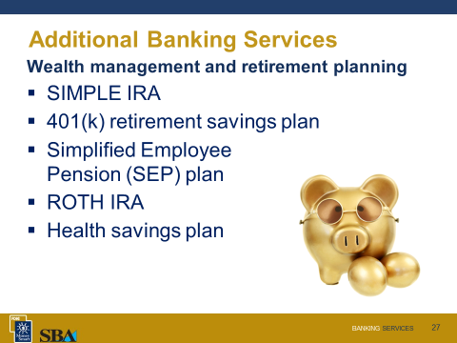  PG | Starting a retirement savings plan can be easier than most business owners think. By starting a retirement savings plan, you will help your employees save for the future. What’s more, retirement programs can provide tax advantages to both employers and employees. You can establish a plan even if you are self-employed. Banks provide a number of ways to provide for retirement and it is important to speak with a financial advisor to determine the best plan or combination for you and your business.  There are three key types of IRA-based options:  - Simplified Employee Pension (SEP) plans are available for any size business. Only the employer contributes to the retirement plan—the employer can contribute up to 25 percent of each employee’s pay. Contributions to a SEP are tax deductible and your business pays no taxes on the earnings on the investments.  - SIMPLE (Savings Incentive Match Plan for Employees) plans allow a business that has 100 or fewer employees to help employees save for retirement. Employees can contribute to the IRA, on a tax-deferred basis, through payroll deductions. As the business owner, you can choose either to match the employee’s contributions or to contribute a fixed percentage of all eligible employees’ pay.  - Payroll Deduction IRAs: Even if an employer does not want to adopt a retirement plan, it can allow its employees to contribute to an IRA through payroll deductions. The employer sets up the payroll deduction IRA program, and then the employees choose whether and how much they want deducted from their paychecks and deposited into the IRA. The employee makes all of the contributions. There are no employer contributions.  Another retirement plan option is the 401(k) Plan. A 401(k) plan allows participants to decide how much to contribute to their accounts, and employers are entitled to a tax deduction for any contributions they make to employees’ accounts. The money contributed may grow through investments in stocks, bonds, mutual funds, money market funds, savings accounts, and other investment vehicles. Contributions and earnings generally are not taxed by the Federal Government or by most State governments until they are distributed. Banks that provide 401(k) retirement savings products will generally assist you in setting them up with your employees and even provide education for your employees on important features of the plan.
 | Building Your Banking Relationship
PG | After You Select a Bank  Building a banking relationship is just like any other relationship. It doesn’t happen in one day. Once you select the bank that will handle your banking needs, take time to develop a relationship with your banker—the loan officer or manager who handles your account. A good relationship with a key person at your bank can help you establish or increase credit, save you money in fees, and enhance your business opportunities through taking advantage of the banker’s contacts. Clear, frequent, open lines of communication are a necessary component of a strong owner-banker relationship. Talk to your banker at least quarterly, but be sure to talk to your banker when something important occurs, such as winning a major account or gaining a major competitor.  If you have a start-up, spend time educating that person about your business. If you’ve got an on-going enterprise, invite the lender to your company for a tour. Give that person a chance to become interested in your business and your prospects.
5 Minutes | Conclusion
Slides 28 and 29  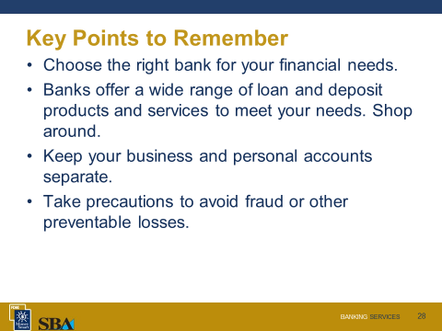  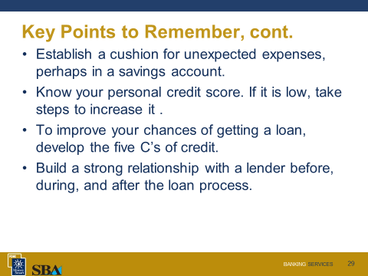  PG | Key Points to Remember  - Choose the right bank for your financial needs. The products and services that banks offer, and the fees that may be charged for those services, can vary between banks. It pays to compare what your bank offers to what several other banks serving your community offer.  - Banks offer a wide range of loan and deposit products and services to meet your needs. For example, you may be able to deposit checks into your account from your office without visiting the bank. If you need to borrow money, consider SBA-guaranteed loan programs.  - Banks can help your business run more smoothly with merchant, payroll, retirement and online services.  - Keep your business and personal accounts separate.  - Take precautions to avoid fraud or other preventable losses.  - Establish a cushion for unexpected expenses, perhaps in a savings account.  - Know your personal credit score. If it is low, take steps now to increase it.  - To improve your chances of getting a loan, develop the five C’s of credit.  - Build a strong relationship with a lender before, during, and after the loan process.
10 minutes | Summary, Post-Test, Evaluation
Slide 30  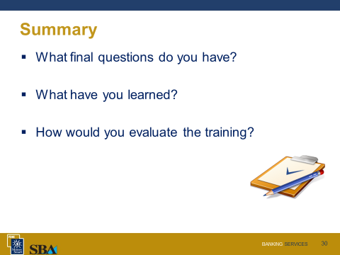 | We have covered a lot of information.  What final questions do you have?
Slide 31  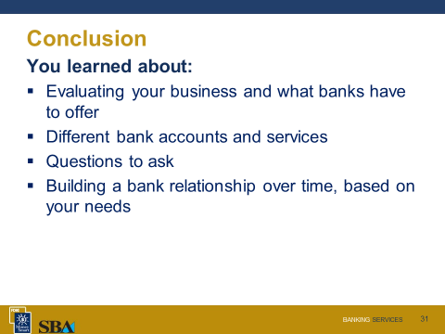 | You learned about:  - Evaluating your business and what banks have to offer  - Different deposit products including sweep features, remote scanners, Automated Clearing House (ACH) debit processing, and wire transfers  - Questions to ask regarding deposit, savings, loan, payroll, merchant, cash management, and retirement services  - How bank services can help you maintain reports and access records for reconcilements  - Cards issued for checking and credit accounts  - Services that can help prevent fraud or forgery  - Building a bank relationship over time, based on your needs
Slide 32  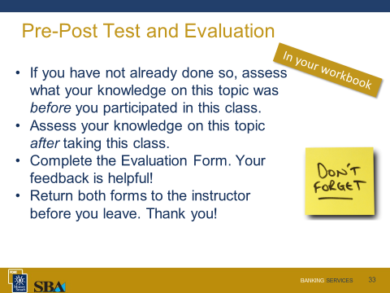 | Post Test and Evaluation  We would like your feedback about this class.  Please complete and return the Evaluation Form on the last page of the Participant Guide.
Assess | What Do You Know? Form  The What Do You Know? form on page 4 of your participant guide lets you compare how much you knew before the class and how much you have learned. Please take a few minutes now to complete the “After the Training” column. Which statements can you answer with “agree” or “strongly agree”?  Post-Test  Take a few minutes to complete the Post-Test beginning on page 27 of your participant guide. Check to see how many answers you can provide now that you have attended this class.

Sample Post-Test
- Note that the correct answers are in bold.
Now that you’ve gone through the training, see what you’ve learned.

- Which of the following is NOT a banking service? Select all that apply.
  - Business checking
  - Business debit card
  - Business credit card
  - Real estate sales
  - Financing receivables
  - Line of credit
  - Term loan
  - Cash management
  - Merchant services
  - Payroll processing
  - Financing fixed assets
  - Wealth management (SIMPLE IRA, 401(k), SEP)

- Fundamentally, how many basic types of business checking accounts are there?
  - Two – small business and commercial
  - Three – small business, commercial and investment
  - Four – small business, commercial, investment and savings
  - More than four

- To help protect against fraud, most banks can set up a sweep on an operating account that links to a payroll account. The payroll account will have what’s known as a ____________________.
  - Bond protection feature
  - Zero balance feature
  - Call provision feature
  - Checking account reconciliation feature

- Which of the following is typically the minimum requirement to open a CD with a bank?
  - $100 – $200
  - $500 – $1,000
  - $2,000 – $4,500
  - $5,000 – 10,000

- Most banks will not permit a business payroll to be direct deposited.
  - True
  - False

- Which of the following is a cash management service a bank might provide? Select all that apply.
  - Online banking
  - Sweep account
  - Remote deposit scanner
  - Lockbox service
  - Automatic Clearing House (ACH) debit processing

- Which of the following best describes a lockbox service?
  - A service that maintains records with regard to paying employees
  - A service whereby payments to a business are mailed to and processed by a bank
  - A service for accepting and processing online payments
  - A service that provides a secure place for business valuables, such as ownership documents

- Which of the following best describes the term “loan guarantee”?
  - A promise that a bank makes to keep interest rates a certain level over a contracted period of time
  - A promise to allow a borrower to “back out” of a loan if it does not suit the borrower’s needs
  - A promise that borrower makes to receive a loan
  - A promise to repay a loan, made by an agency, if the borrower does not repay the loan

- Checking accounts can be coded to sweep funds from or to a line of credit.
  - True
  - False

- Direct deposit, ACH debit and credit processing, and wire transfers all provide a quick means to transfer funds online.
  - True
  - False

Evaluation Form
Please fill out this evaluation form for the Banking Services class.
Training Rating
- Overall, I felt the training was (check one):
[ ] Excellent
[ ] Very Good
[ ] Good
[ ] Fair
[ ] Poor
Please indicate the degree to which you agree by circling a number.
 | Strongly Disagree |  | Disagree | Neutral | Agree | Strongly Agree
- I achieved the training objectives. | 1 |  | 2 | 3 | 4 | 5
- The instructions were clear and easy to follow. | 1 |  | 2 | 3 | 4 | 5
- The PowerPoint slides were clear. | 1 |  | 2 | 3 | 4 | 5
- The PowerPoint slides enhanced my learning. | 1 |  | 2 | 3 | 4 | 5
- The time allocation was correct for this training. | 1 |  | 2 | 3 | 4 | 5
- The instructor was knowledgeable and well-prepared. | 1 |  | 2 | 3 | 4 | 5
- The participants had ample opportunity to exchange experiences and ideas. | 1 |  | 2 | 3 | 4 | 5
Please indicate the degree of knowledge/skill by circling a number. | None Advanced
- My knowledge/skill level of the subject matter before taking the training. | 1 |  | 2 | 3 | 4 | 5
- My knowledge/skill level of the subject matter upon completion of the training. | 1 |  | 2 | 3 | 4 | 5
Instructor Rating
- Instructor Name:
Please use the response scale to rate your instructor by circling a number. | Poor | Fair |  | Good | Very Good | Excellent
- Made the subject understandable. | 1 |  | 2 | 3 | 4 | 5
- Encouraged questions. | 1 |  | 2 | 3 | 4 | 5
- Provided technical knowledge. | 1 |  | 2 | 3 | 4 | 5
- What was the most useful part of the training?
___________________________________________________________________________________________________________________________________________________________________________________

- What was the least useful part of the training and how could it be improved?
____________________________________________________________________________________________________________________________________________________________________________________

